***Made by- Nitanshu Tak***

**Cloud Computing Fundamentals Project**

[**AWS InfraControl CLI Tool**](https://github.com/Nitanshu715)

1. **Introduction**

With rapid advances in technology, cloud computing has found a pivotal place in the IT ecosystem, ensuring it is scalable, reliable, and affordable. This project aims to use cloud computing with the benefits of Amazon Web Services (AWS) to build a complete and automated system not only to log EC2 instance state changes but securely store this data and promptly notify the user via email. The thrust of this report is to detail the implementation of this project from start to finish, summarizing all the important aspects of the planning, execution, challenges, and the eventual outcome.

1. **Basic Principles of Cloud Computing and AWS**

Cloud computing, as that term is conventionally understood, implies use of the Internet ("the cloud") to deliver computing services-from applications to fully-fledged data centers. Cloud computing thus allows rapid innovation, flexible resources, and economies of scale. AWS (Amazon Web Services) stands out among the important cloud platforms, boasting over 200 services in active deployment across global data centers. AWS infrastructure solutions- IaaS, platform solutions PaaS, software solutions SaaS-extend the capability to deploy applications and services easily and quickly with value-in-kind.

1. **Project Definition and Scope**

The purpose of this project, on the one hand, is to automate the monitoring of Amazon EC2 (Elastic Compute Cloud) instances while also notifying users about state transitions on an instance, such as starting or stopping. The use of AWS services, such as Lambda functions for Automation, S3 bucket for logging, EventBridge for scheduling and event-driven actions, and SNS for notifications, form part of this. The project illustrates the practical applications of serverless architecture and event-driven programming in cloud computing.

1. **Project Goals & Objectives**

* Specific Outcomes Intended from the Project
* To bake an AWS Lambda function for tracking changes in EC2 instance states.
* For these changes to be logged persistently in an Amazon S3 bucket.
* To set up Amazon Simple Notification Service (SNS) for email alerts.
* To automate these processes through EventBridge and CloudWatch events.
* Functional and Technical Goals
* Logging of every event state change of every instance.
* Notify the users through an email with all pertinent information like Instance ID and timestamp.
* Store the logs securely, and have them durable in S3.
* Keep manual intervention to a minimum by automation tools.
* AWS Services utilized & their configurations

1. **IAM Roles and Permission setup**

The IAM role has been directly created on the AWS Console without JSON policy documents attached to it. With the necessary permissions to EC2, Lambda, CloudWatch, SNS, and S3, it attached the following policies:

* AmazonEC2FullAccess
* AmazonS3FullAccess
* AWSLambdaBasicExecutionRole
* [AmazonEventBridgeFullAccess](https://us-east-1.console.aws.amazon.com/iam/home?region=ap-south-1#/policies/details/arn%3Aaws%3Aiam%3A%3Aaws%3Apolicy%2FAmazonEventBridgeFullAccess)
* [AmazonSNSFullAccess](https://us-east-1.console.aws.amazon.com/iam/home?region=ap-south-1#/policies/details/arn%3Aaws%3Aiam%3A%3Aaws%3Apolicy%2FAmazonSNSFullAccess)
* [AWSBillingReadOnlyAccess](https://us-east-1.console.aws.amazon.com/iam/home?region=ap-south-1#/policies/details/arn%3Aaws%3Aiam%3A%3Aaws%3Apolicy%2FAWSBillingReadOnlyAccess)
* [AWSLambda_FullAccess](https://us-east-1.console.aws.amazon.com/iam/home?region=ap-south-1#/policies/details/arn%3Aaws%3Aiam%3A%3Aaws%3Apolicy%2FAWSLambda_FullAccess)
* [IAMFullAccess](https://us-east-1.console.aws.amazon.com/iam/home?region=ap-south-1#/policies/details/arn%3Aaws%3Aiam%3A%3Aaws%3Apolicy%2FIAMFullAccess)

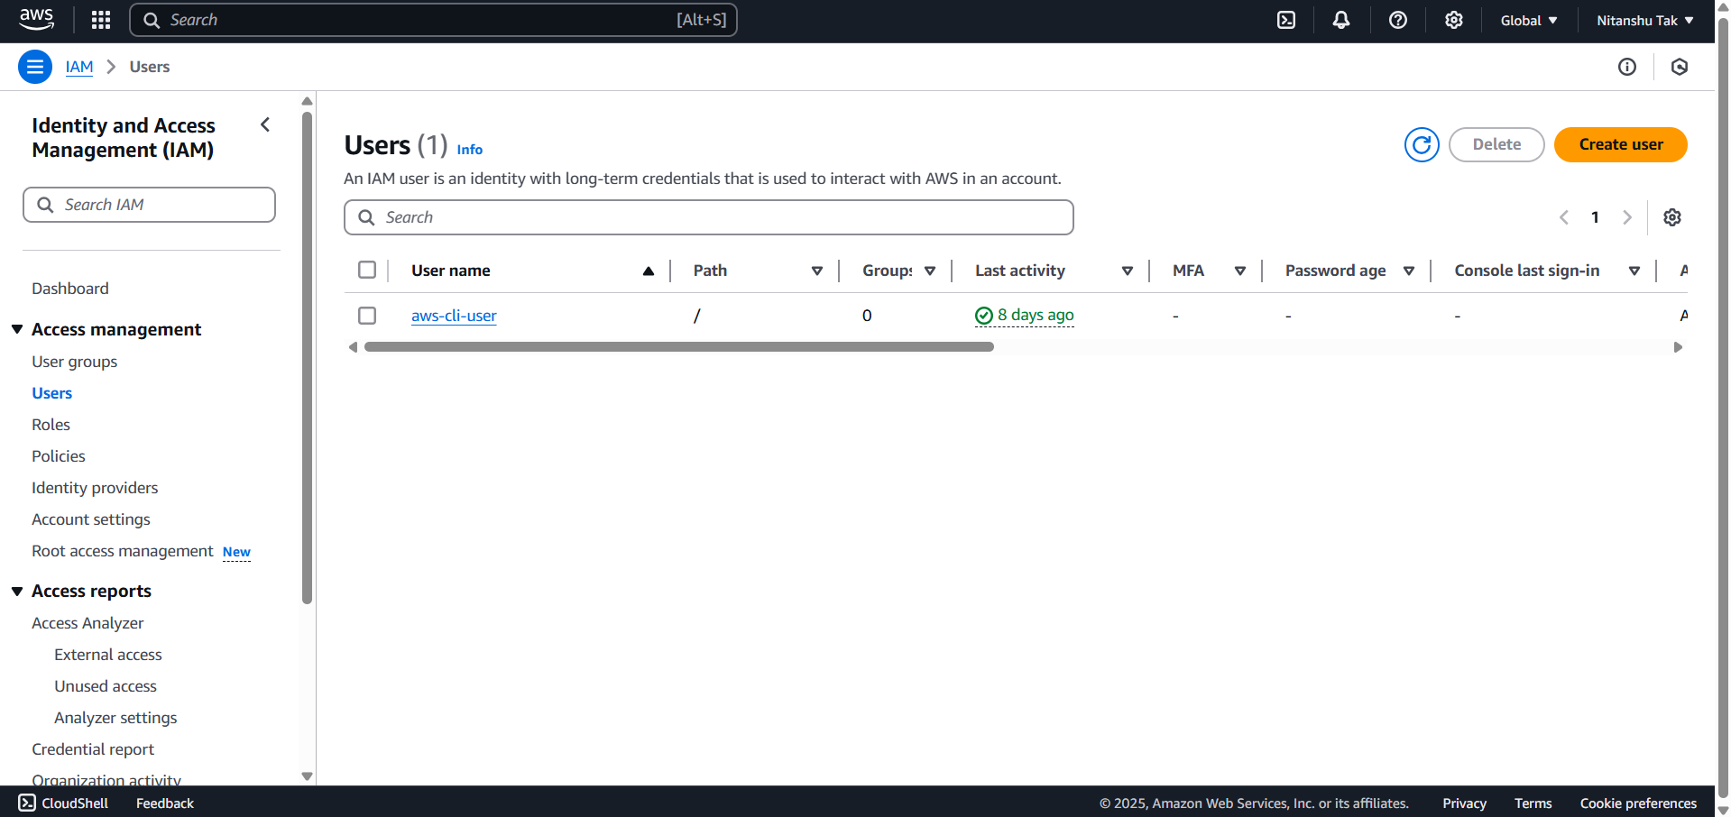

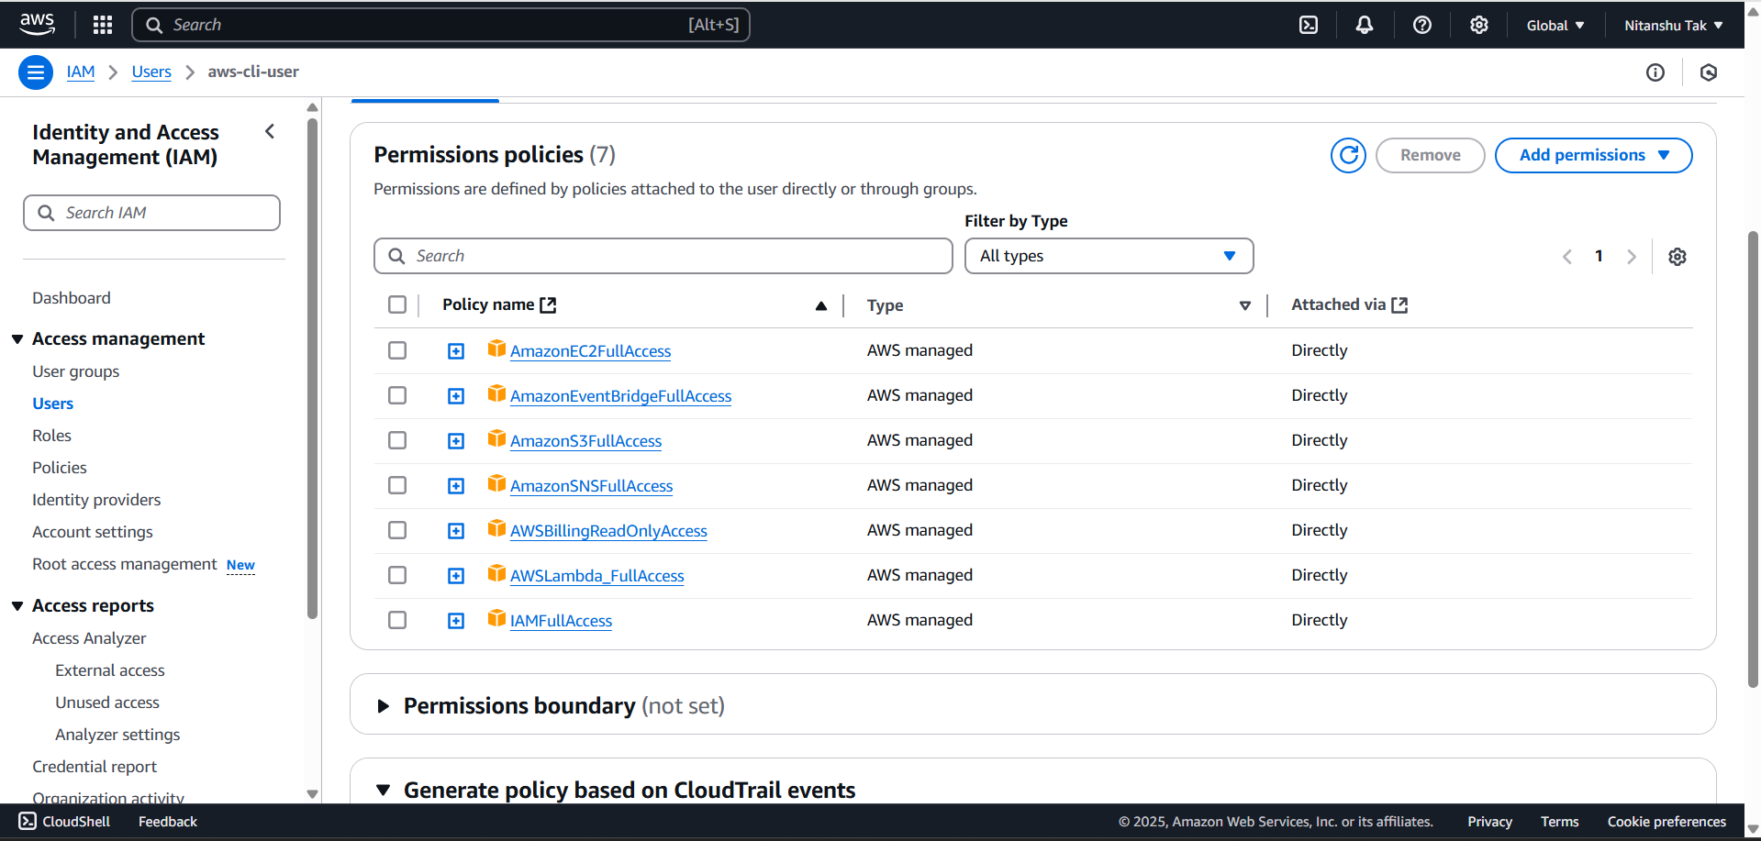

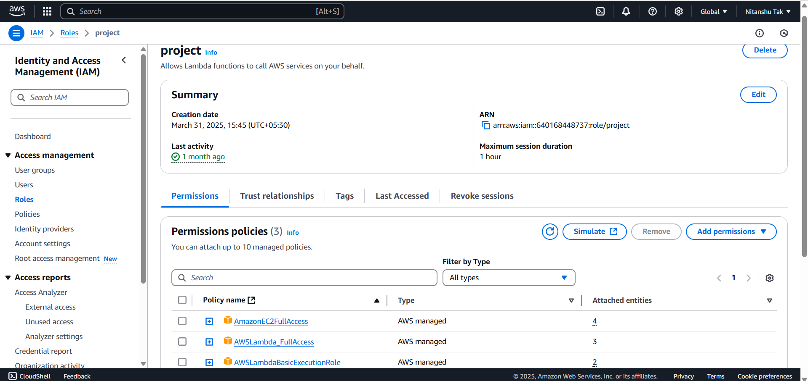

1. **Configuration of EC2 Instances**

The EC2 instance was created on AWS Console. Instance type, key pair, security group and network configuration were selected. Then we monitored the state change of instances using Cloud Watch events. You'll find the details below.

1. **S3 Bucket Configurations**

A bucket named group20-ec2-logs was created to keep logs of instance state change. This bucket was configured as follows:

- Versioning enabled

- Public access blocked

- Bucket policy to allow Lambda write logs

1. **Lambda Function details**

Lambda function was EC2StateLogger: it was written in Python 3.12 and uploaded as .zip file, the code records state changes of a particular instance and sends this information using S3 SNS. This function uses the boto3 library for interactions with AWS.

1. **Steps Description**

* Created IAM Role via Console with all the necessary managed policies.
* Created EC2 Instance and recorded the Instance ID to carry out monitoring.
* Created S3 Bucket to store log files with secure access control.
* Developed Lambda Function to capture instance state changes.
* Created EventBridge Rule to invoke the Lambda on EC2 state change events.
* Configured SNS Topic and Subscriber to enable notification via email.

1. **Challenges & Solutions**

* Technical/Configuration Issues
* Lambda Role Permission: All required policies were manually attached to the Lambda role to fix the issue.
* S3 Access Denied: Fixed by adding correct permissions to prevent access denial.
* SNS Email Delays: Verified email subscriptions and reconfirmed recipient email.
* EventBridge Not Fired: Made sure that the event pattern was set correctly to capture EC2 state changes.
* Debugging-Resolving
* CloudWatch logs were used to trace Lambda execution.
* Cross verification of role permission and event rules were done manually.
* Function redeployed multiple times to test the different configurations.
* Future Improvements
* This project lays down a strong basis for future improvement. In light of that, possible enhancements could be:
* Adding support for a multicongler and region to be set dynamically.
* A dashboard could be created using Amazon CloudWatch metrics.
* Incorporating AWS Step Functions for workflow management.
* Authentication for log viewing and higher security.

1. **Conclusion**

The project at hand showcased the successful automation of EC2 instance monitoring/notification through AWS Services. We have built a monitoring/notification system through the integration of IAM, EC2, Lambda, S3, SNS, and EventBridge, thus reducing manual workload while providing visibility into cloud operations. Both rounds of the project were successfully completed, starting from simple logging and transitioning to a more advanced solution with real-time notifications and persistent storage.

1. **Screenshots:**

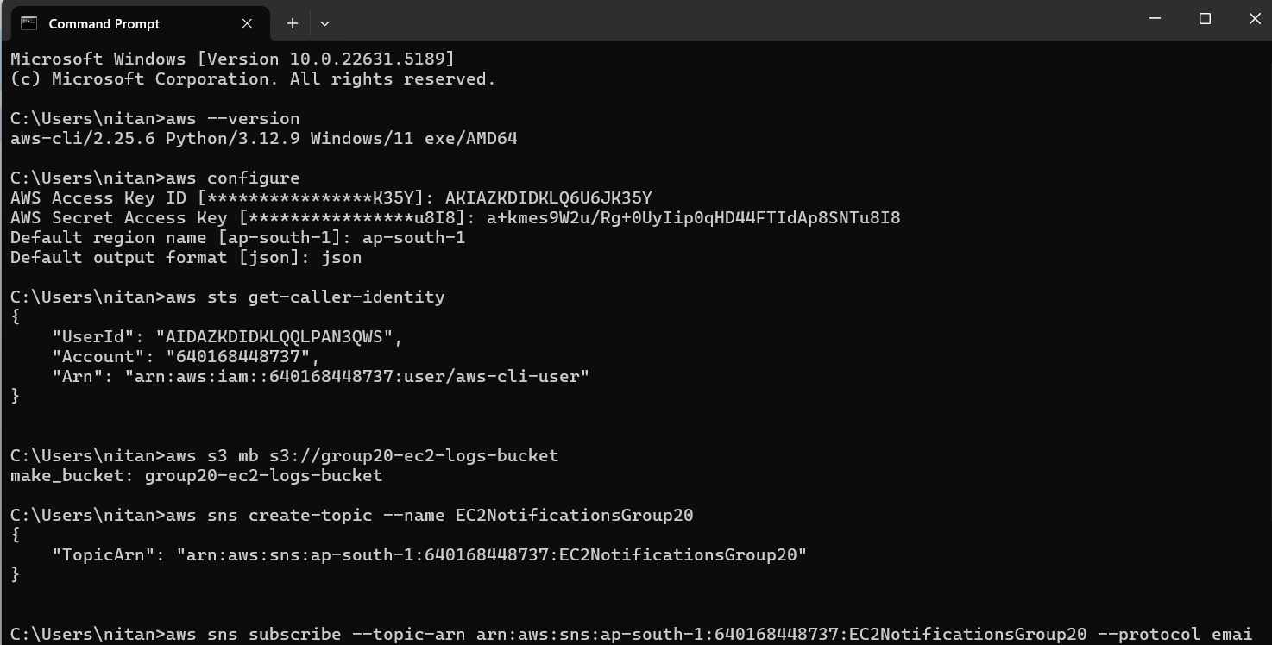

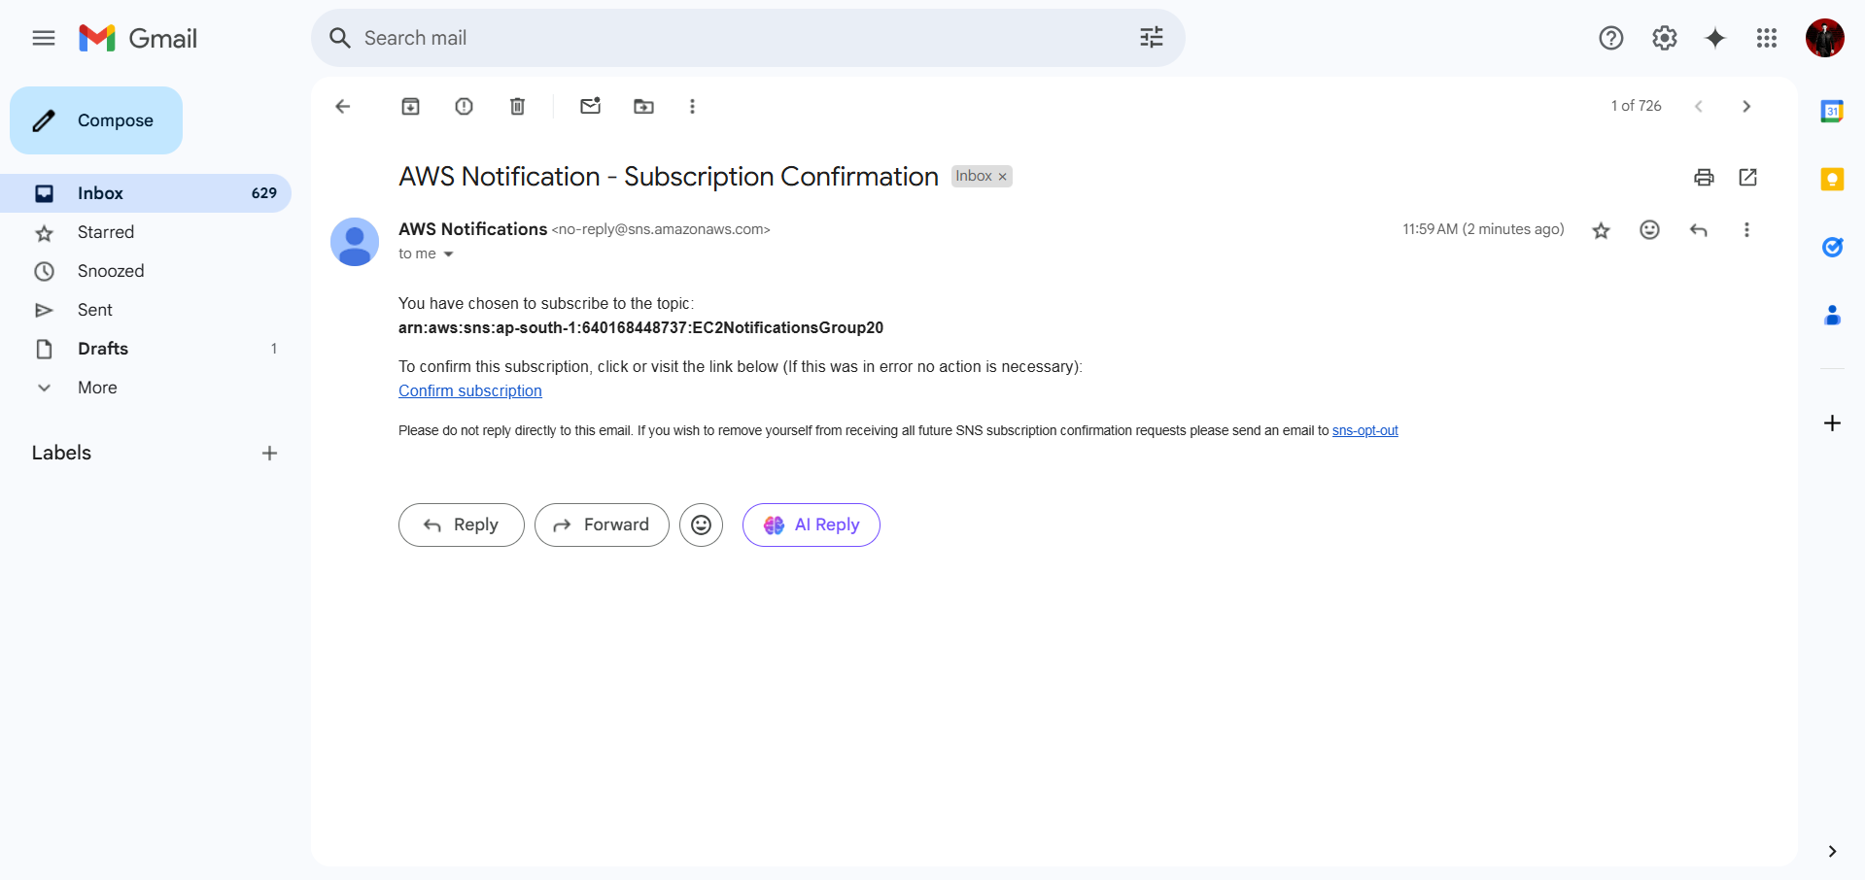

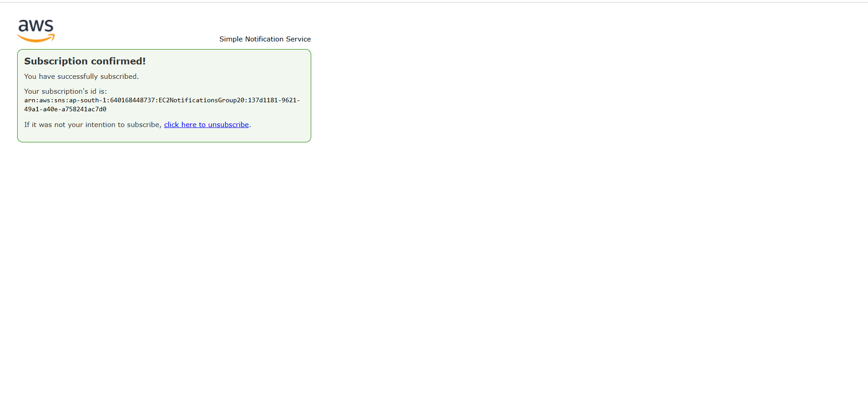

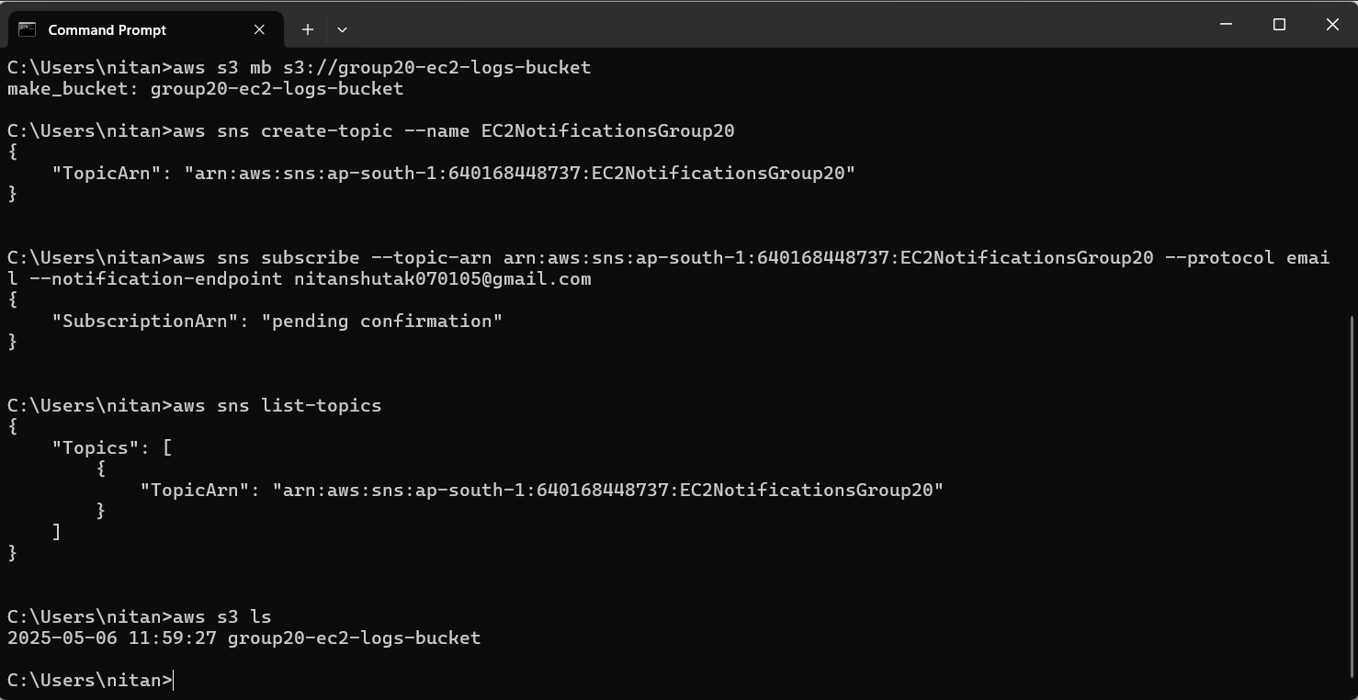

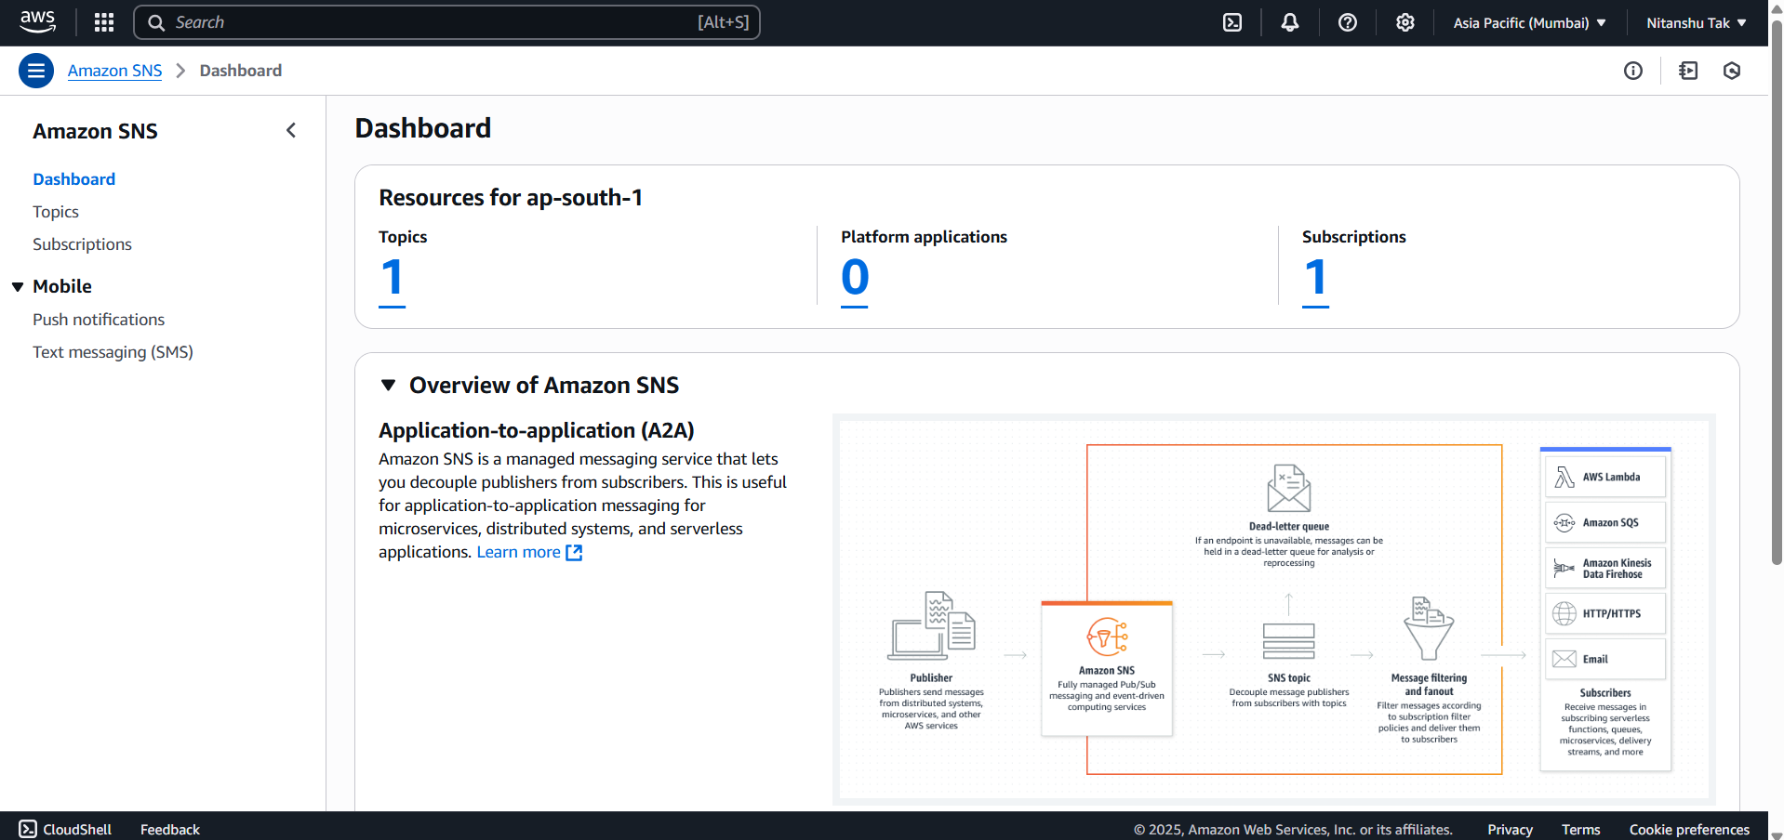

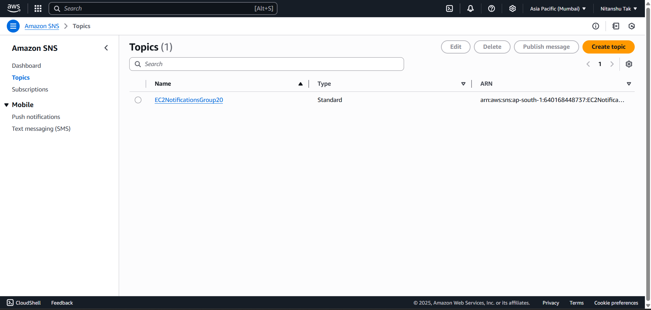

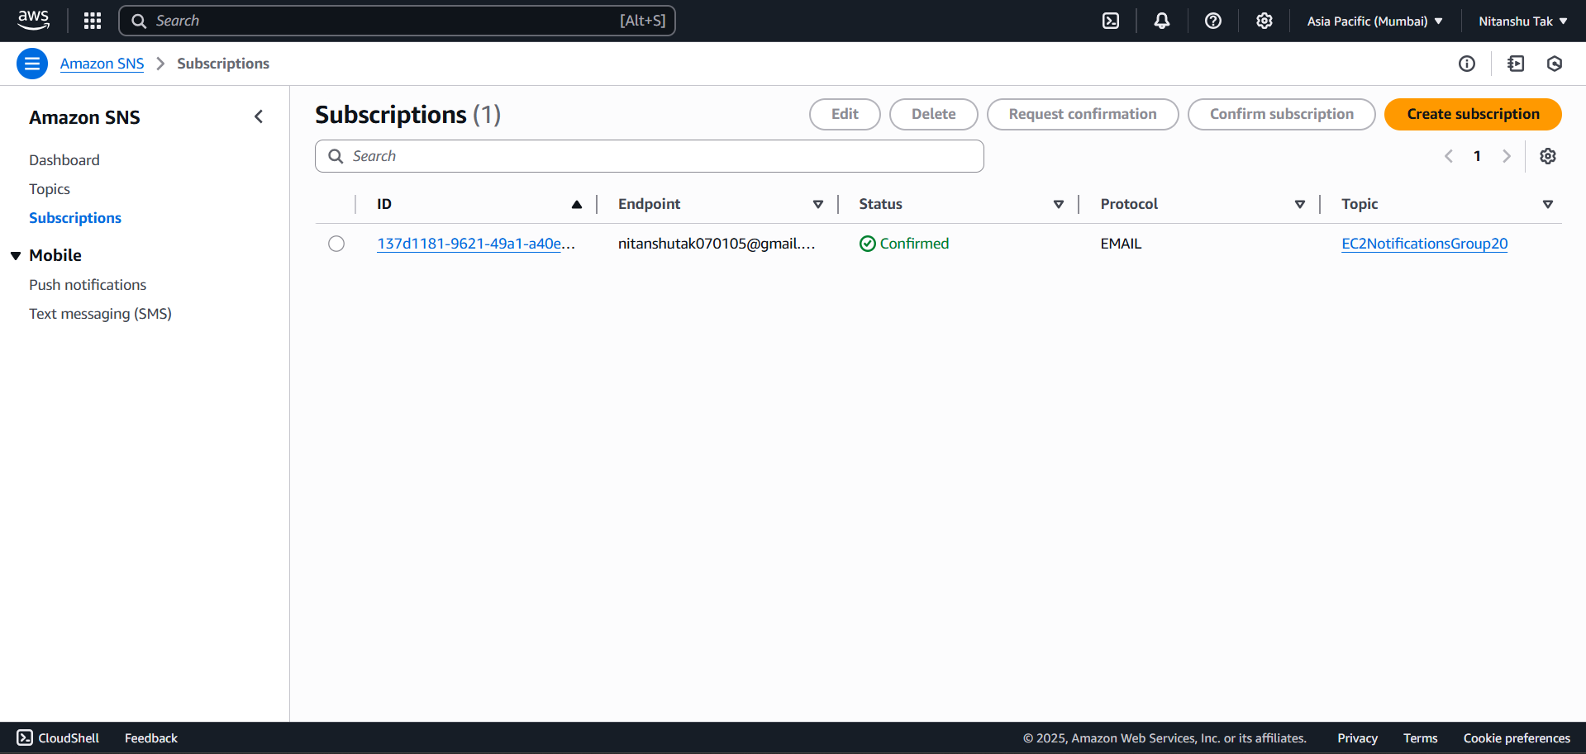

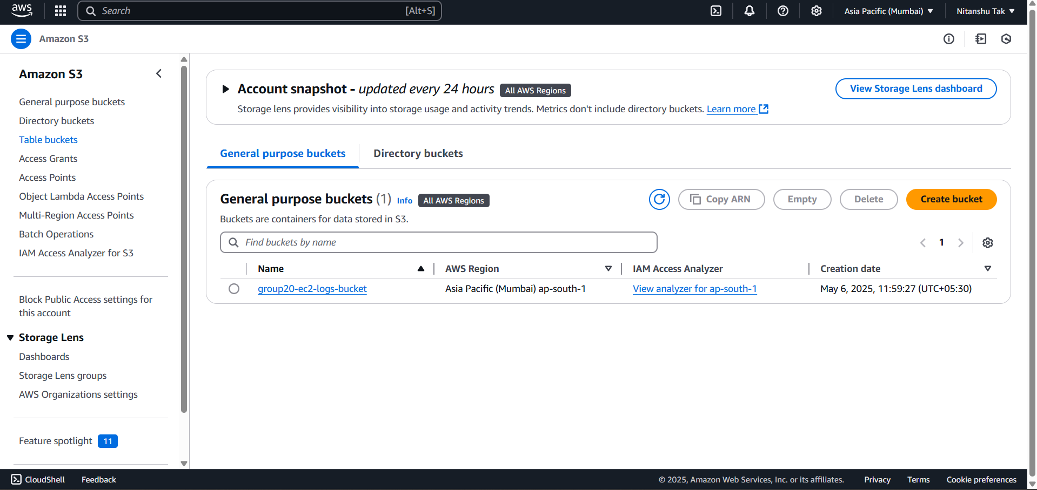

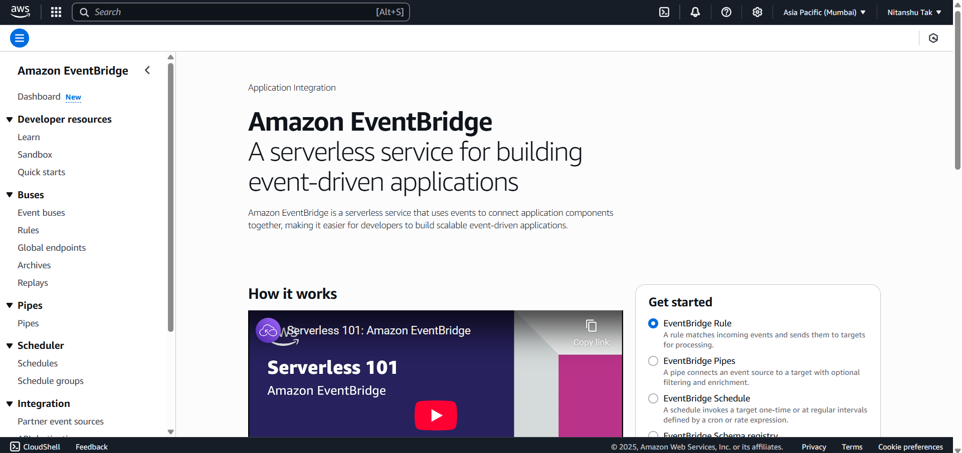

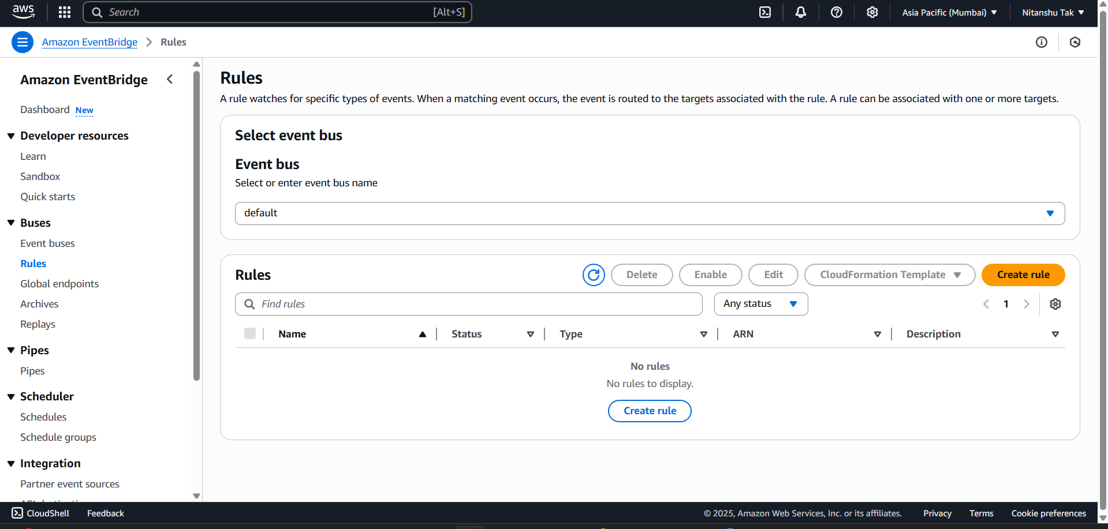

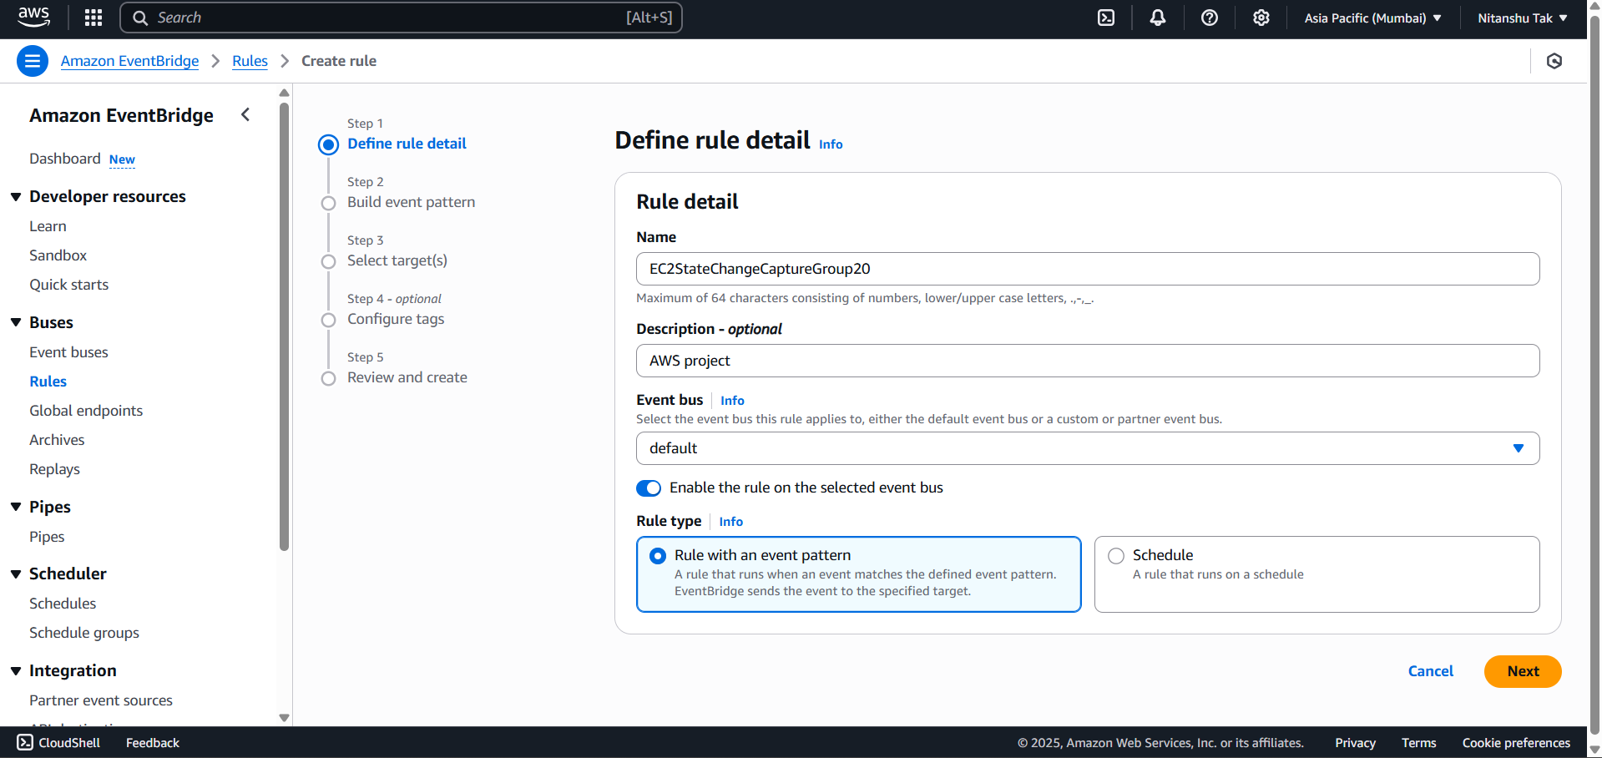

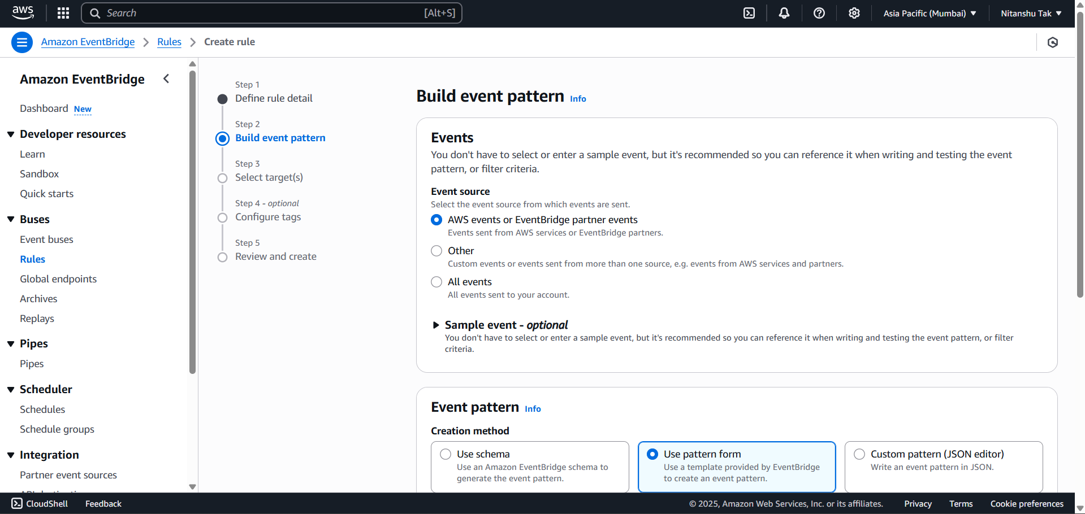

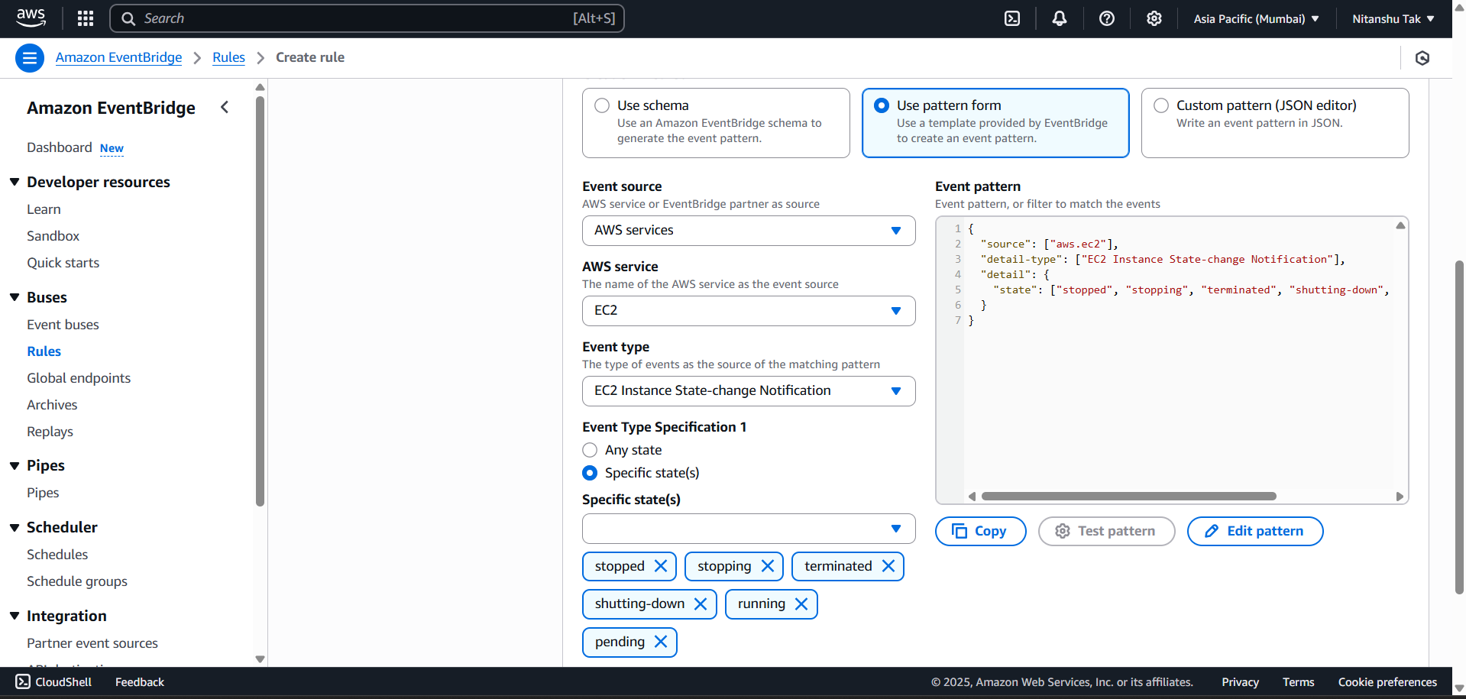

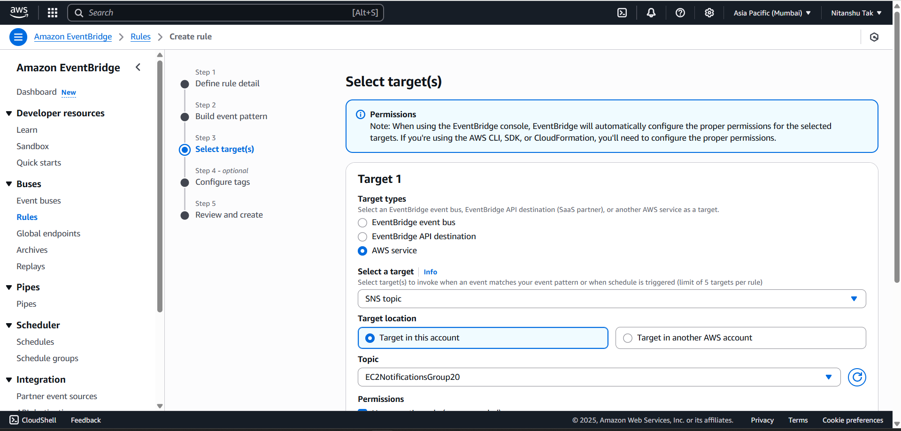

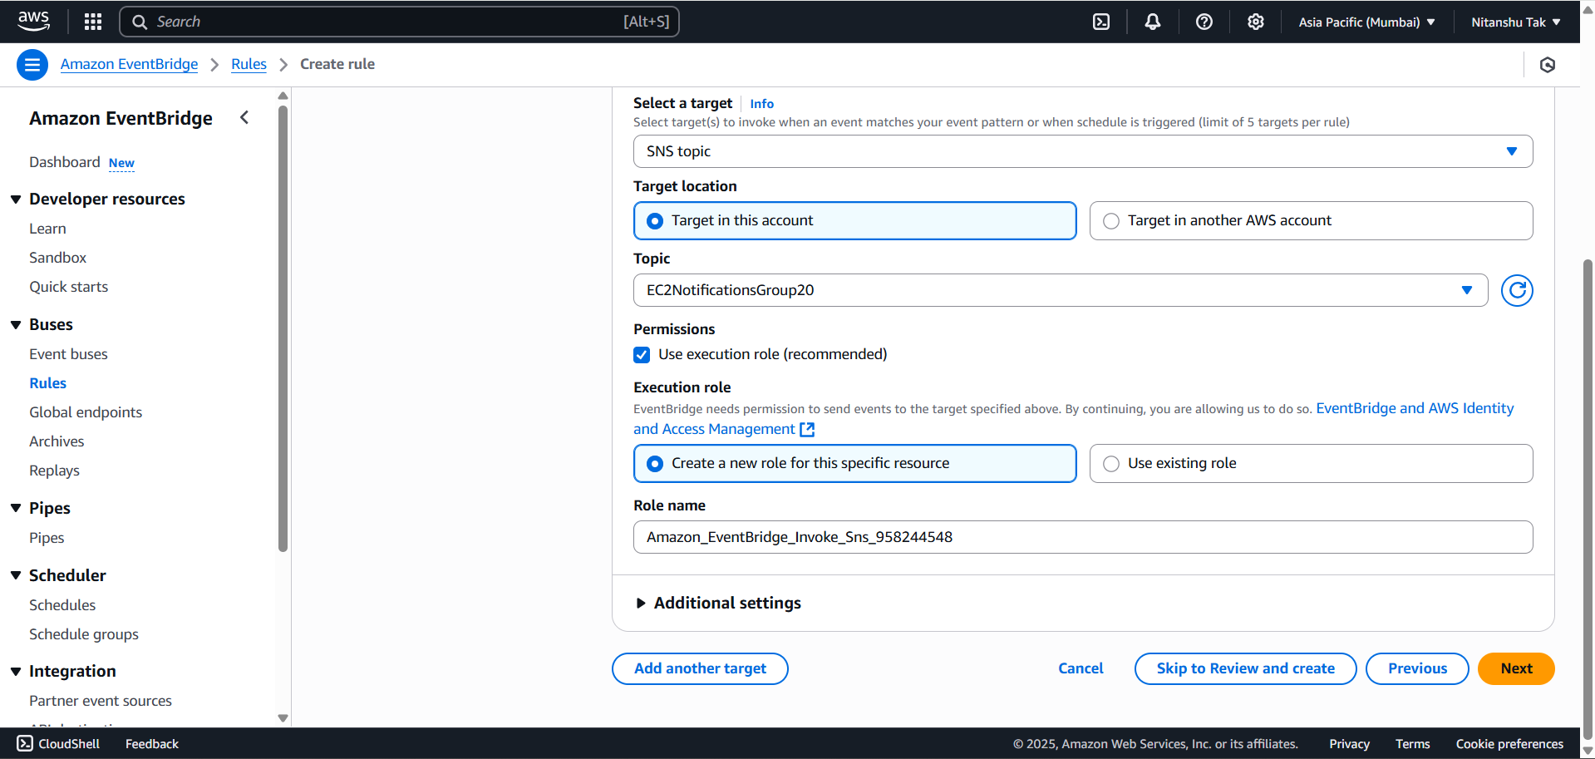

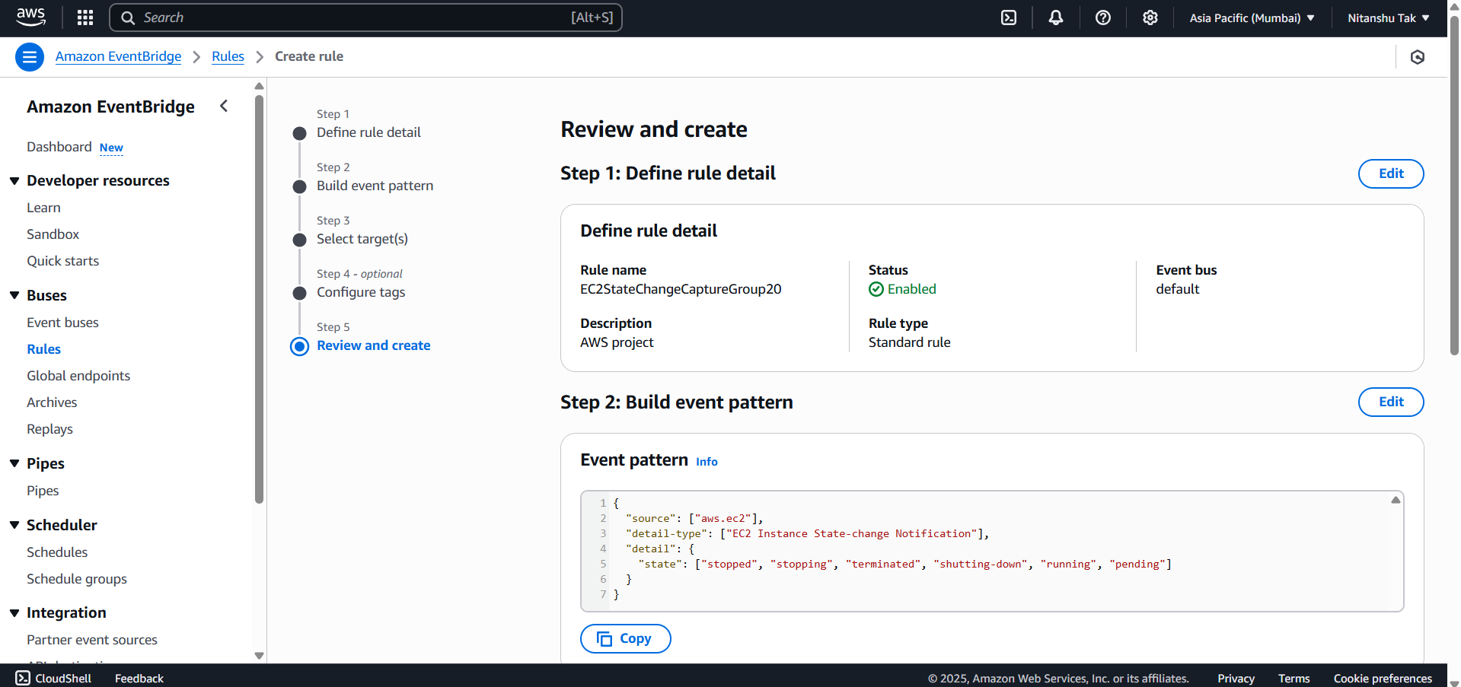

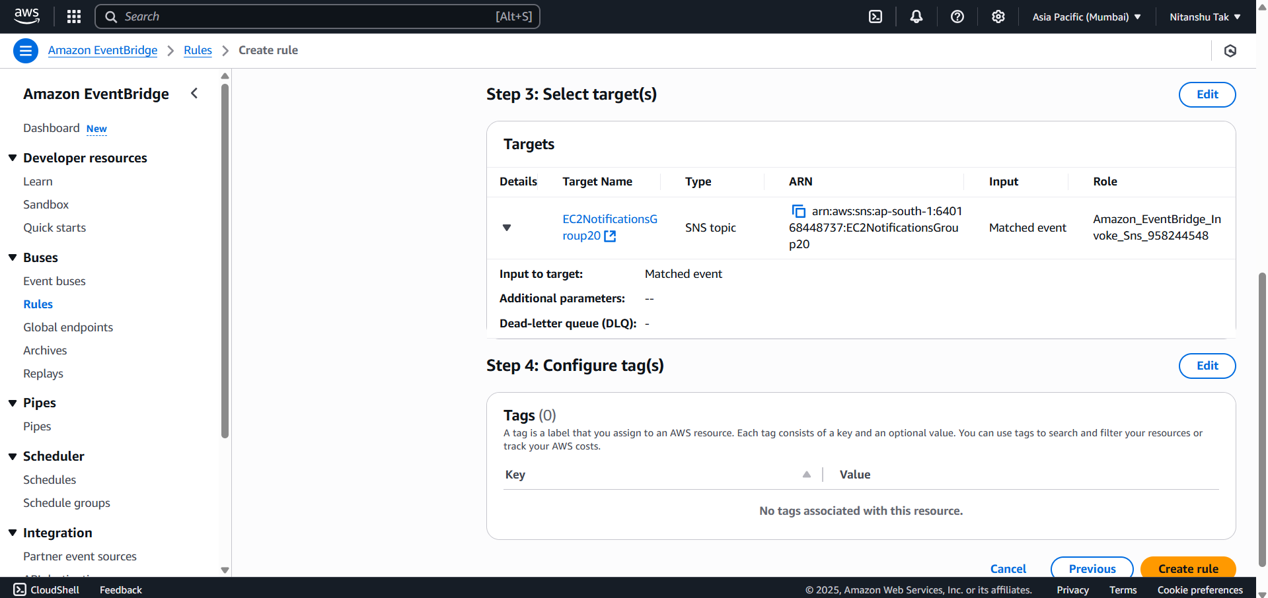

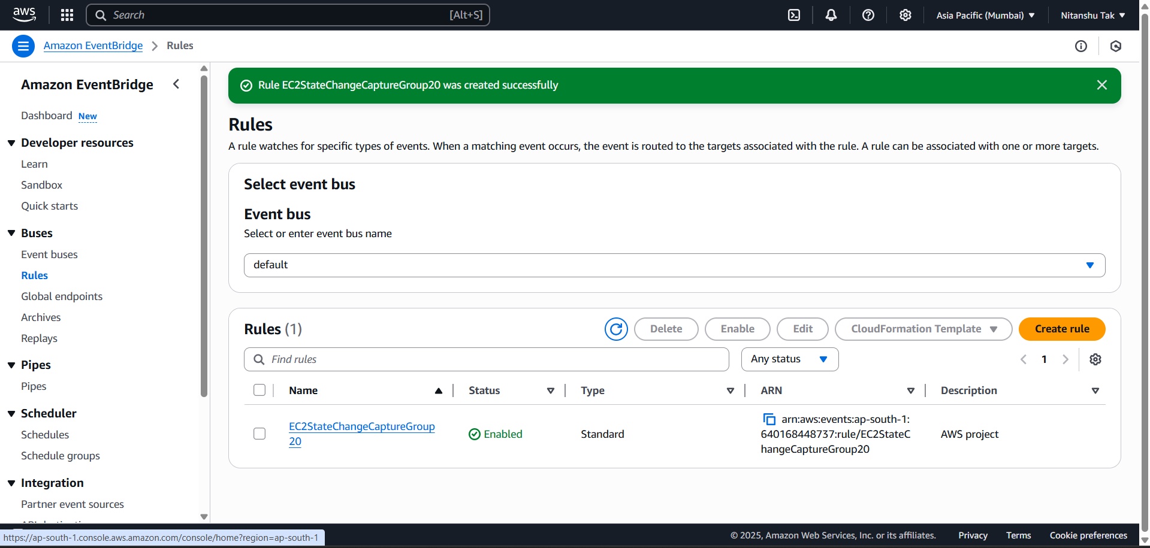

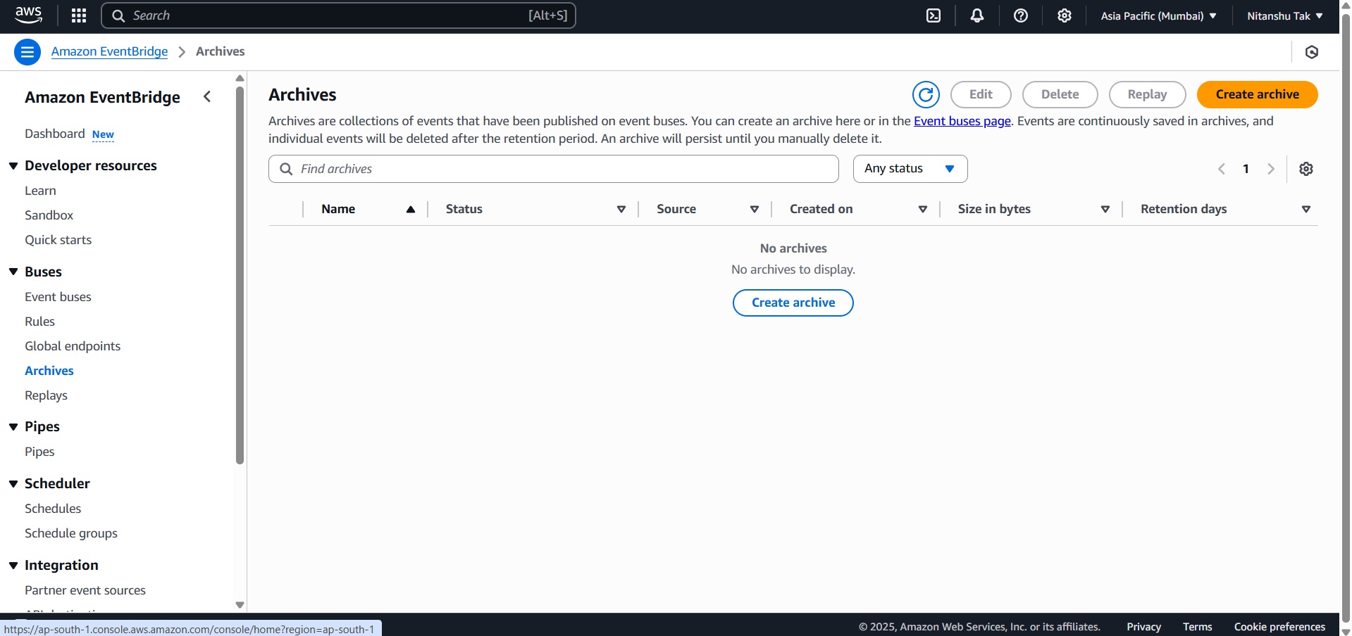

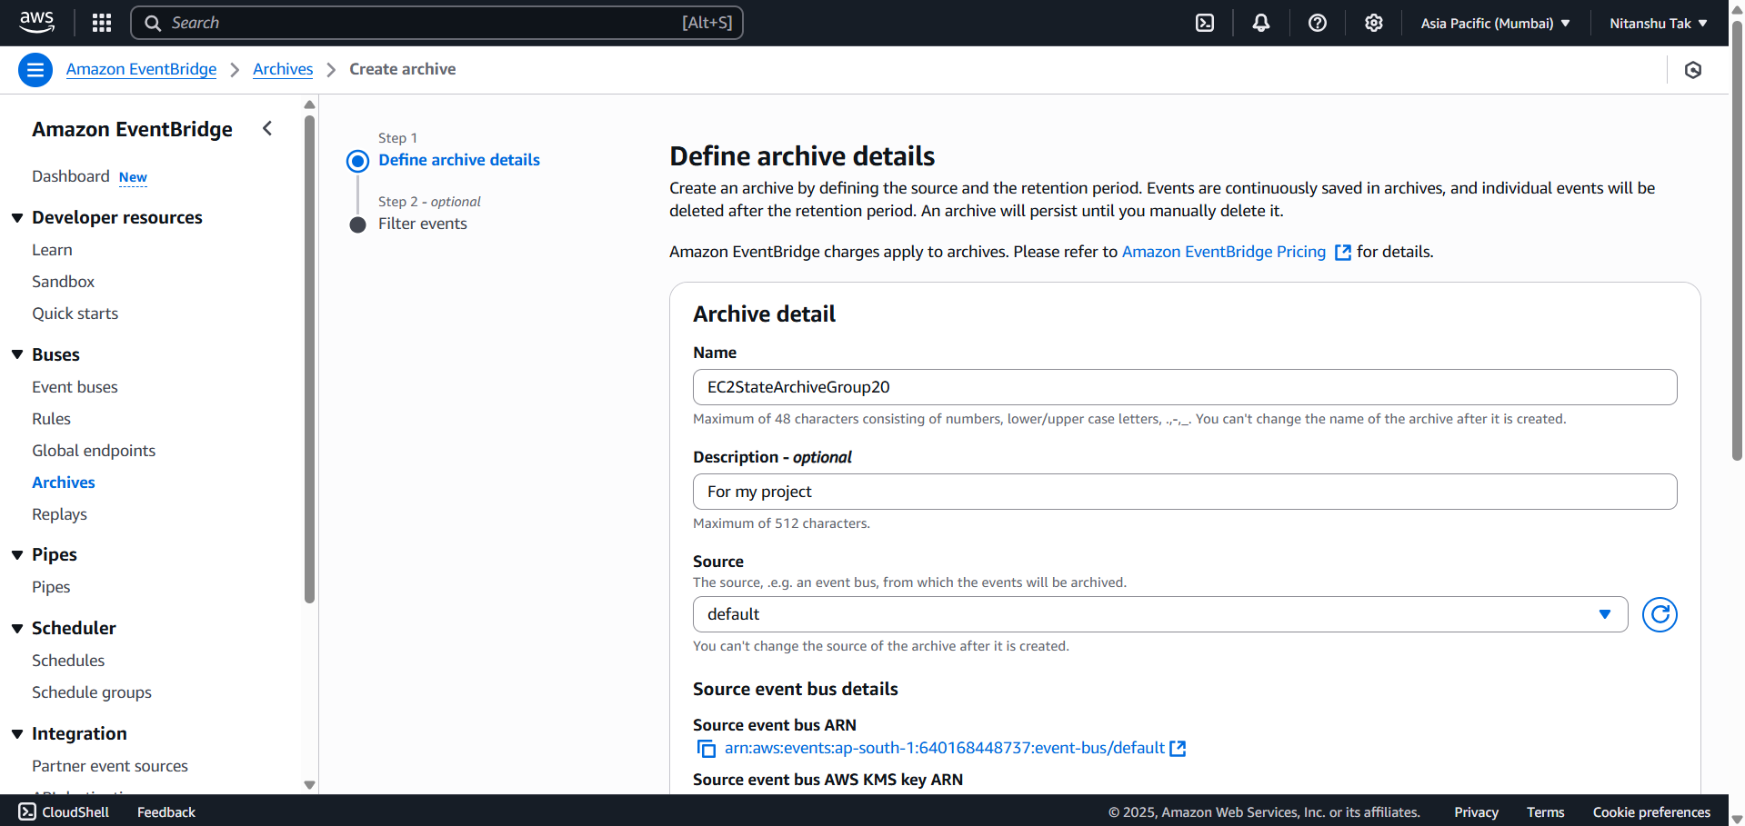

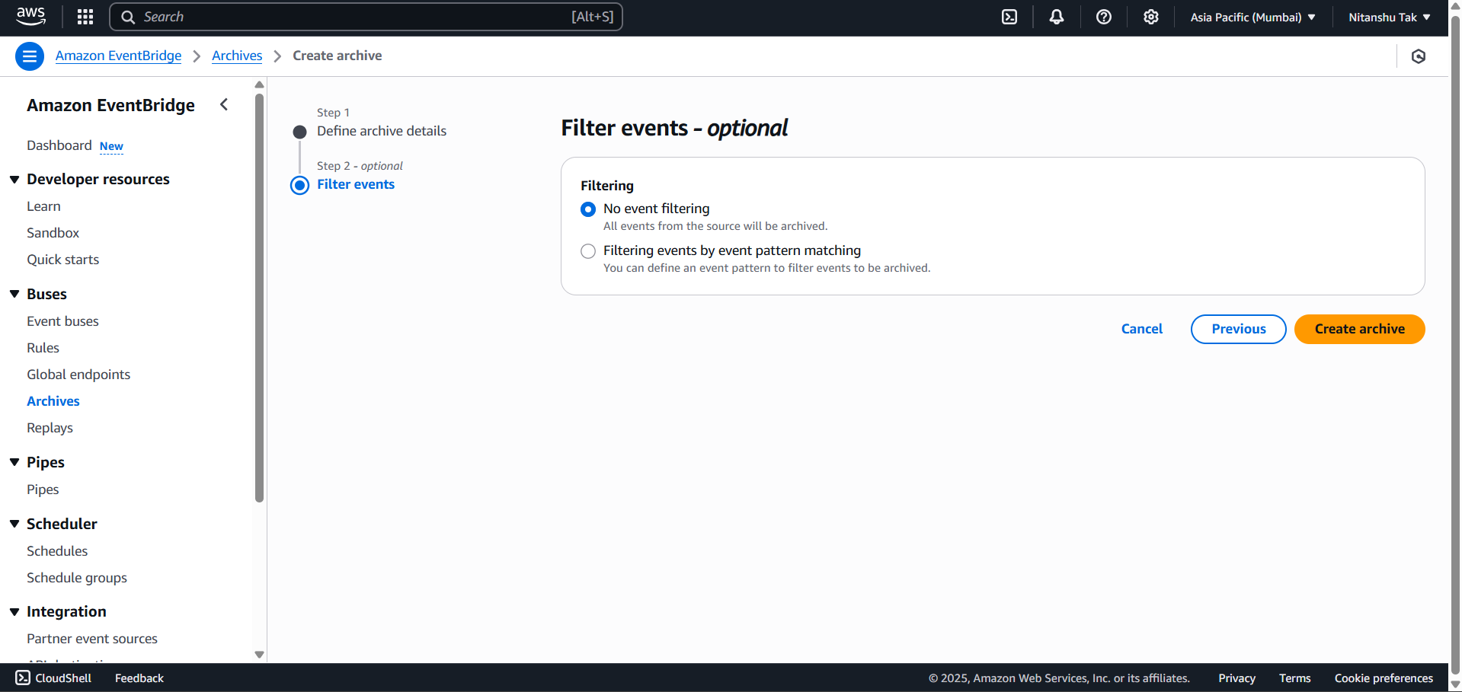

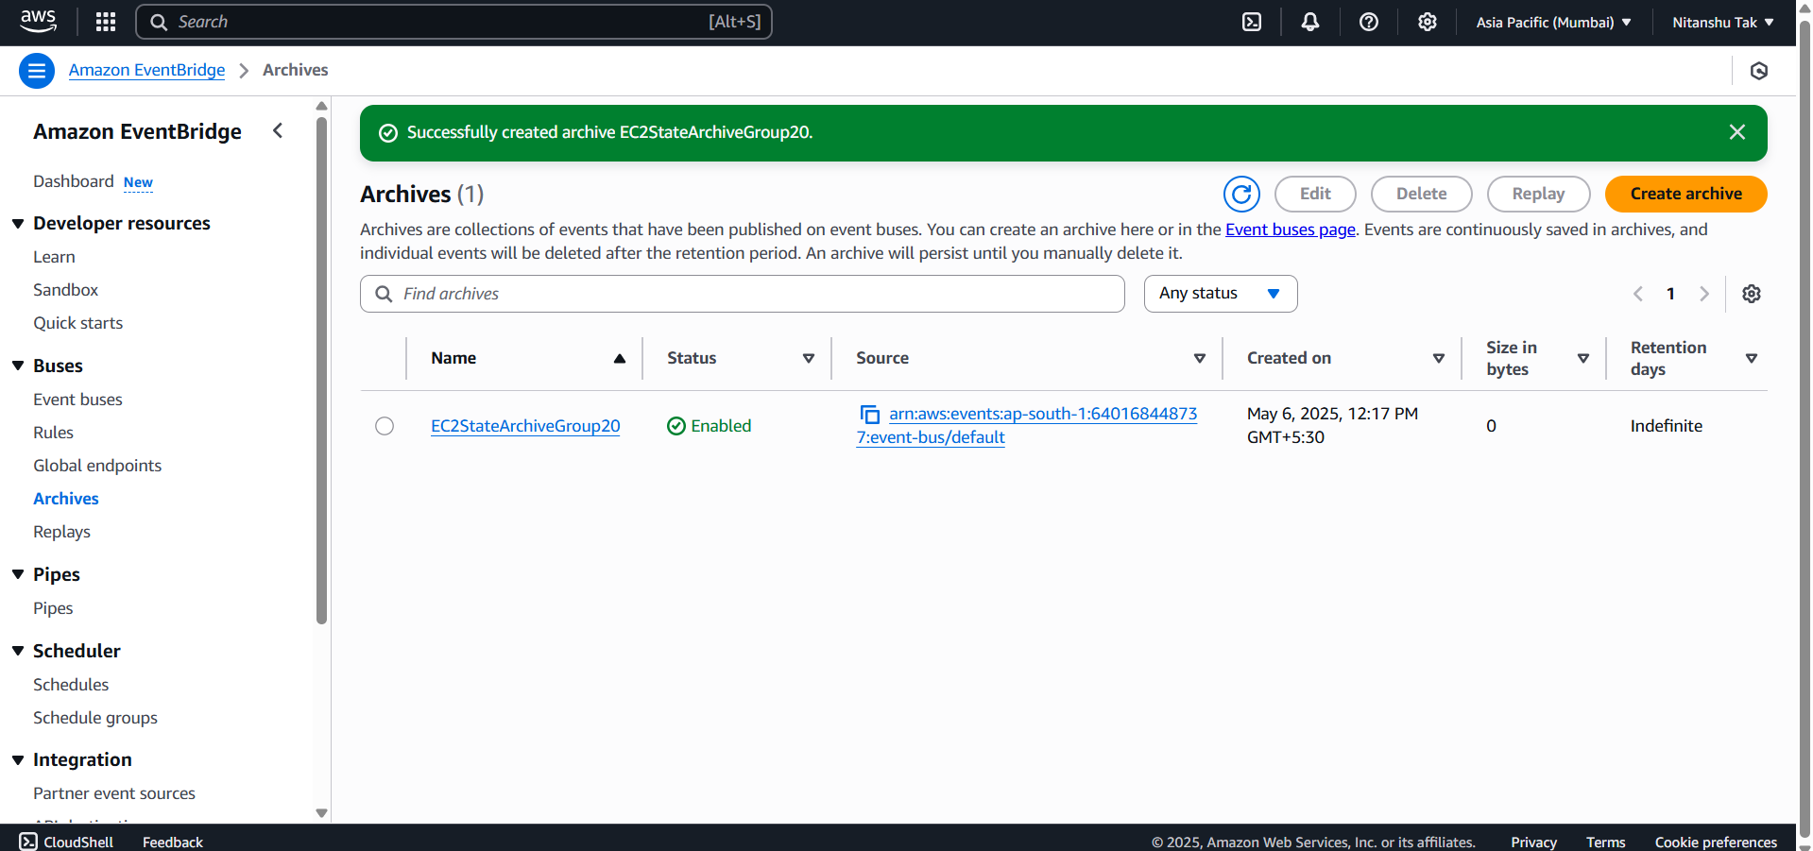

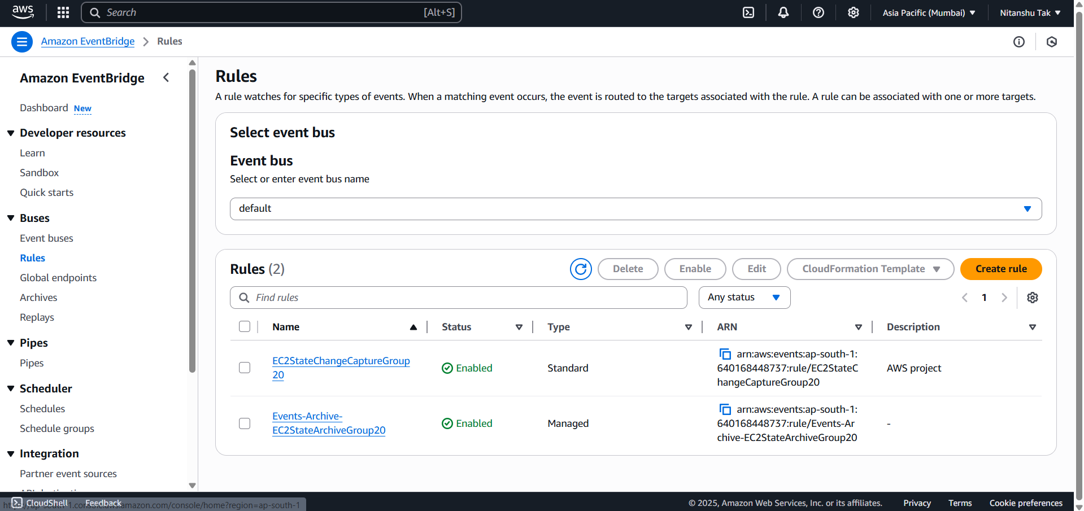

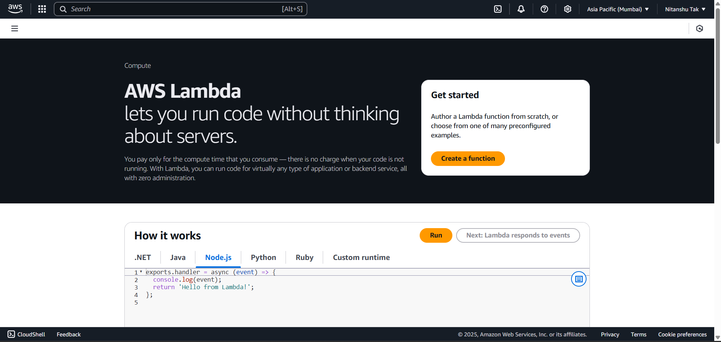

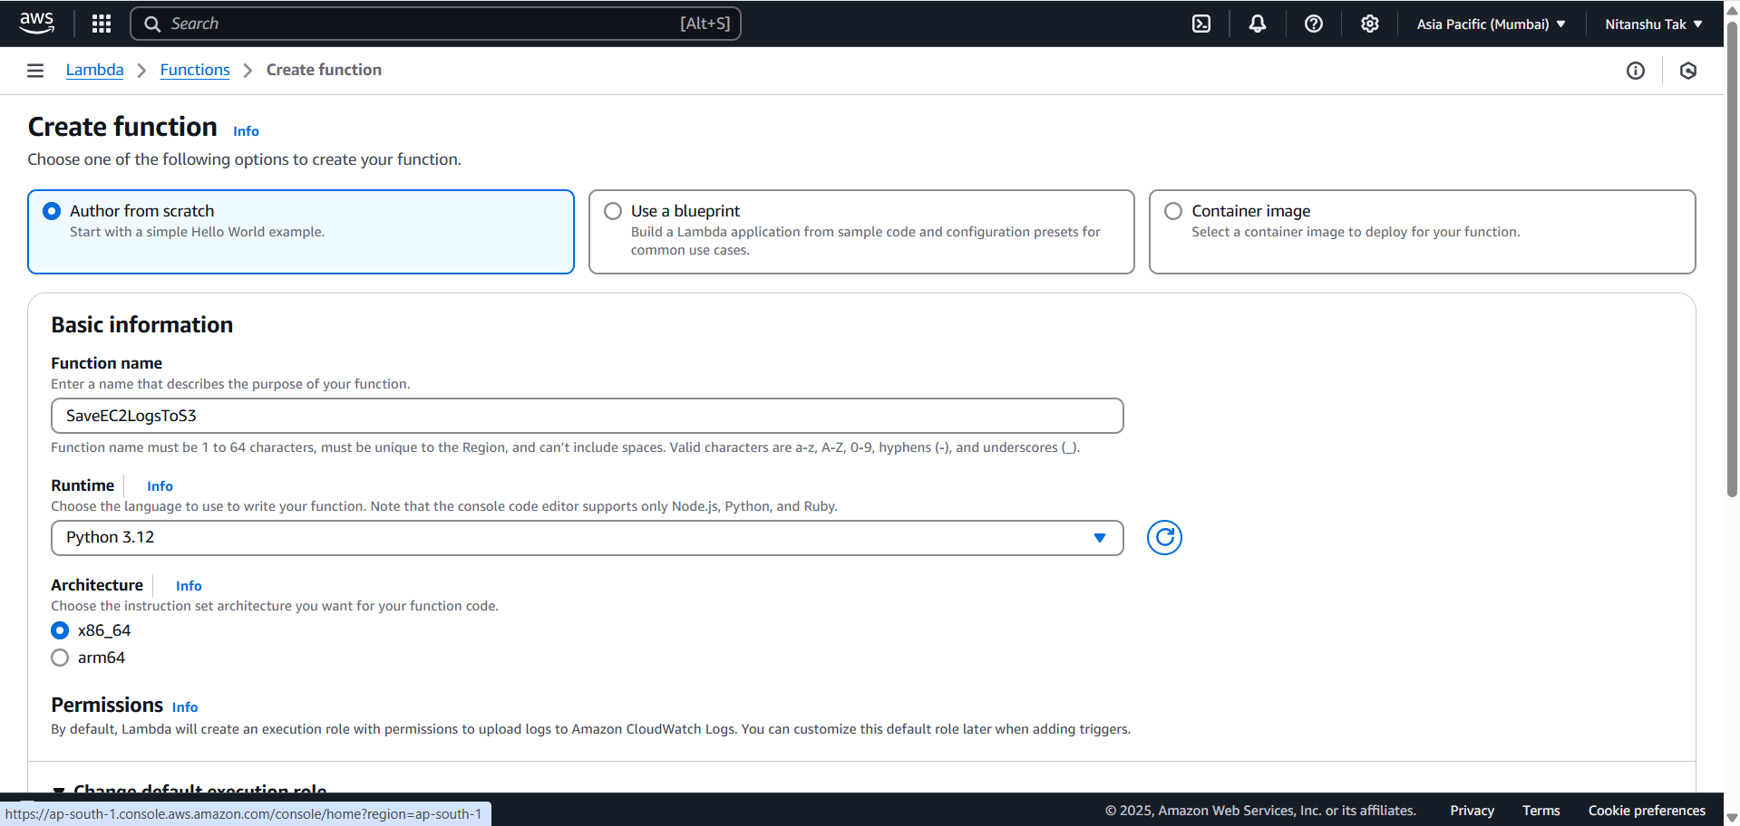

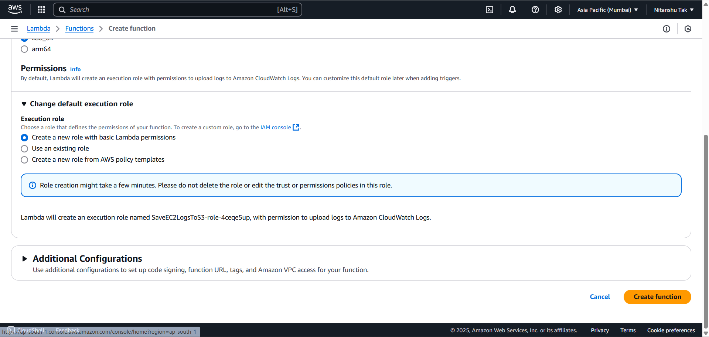

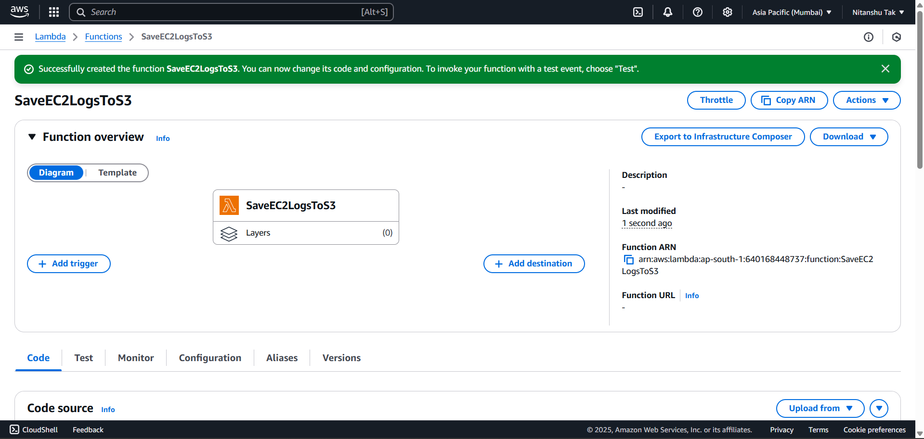

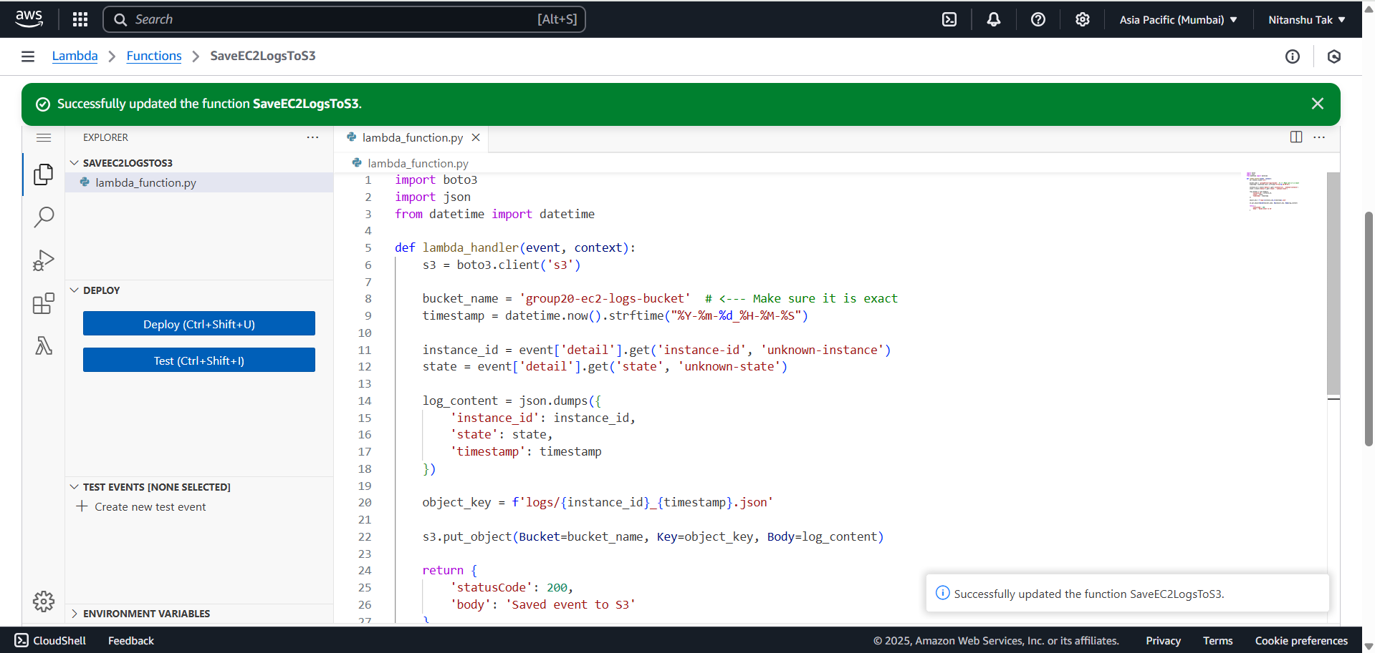

import boto3

import json

from datetime import datetime

def lambda_handler(event, context):

    s3 = boto3.client('s3')

    bucket_name = 'group20-ec2-logs-bucket'  # <--- Make sure it is exact

    timestamp = datetime.now().strftime("%Y-%m-%d_%H-%M-%S")

    instance_id = event['detail'].get('instance-id', 'unknown-instance')

    state = event['detail'].get('state', 'unknown-state')

    log_content = json.dumps({

        'instance_id': instance_id,

        'state': state,

        'timestamp': timestamp

    })

    object_key = f'logs/{instance_id}_{timestamp}.json'

    s3.put_object(Bucket=bucket_name, Key=object_key, Body=log_content)

    return {

        'statusCode': 200,

        'body': 'Saved event to S3'

    }

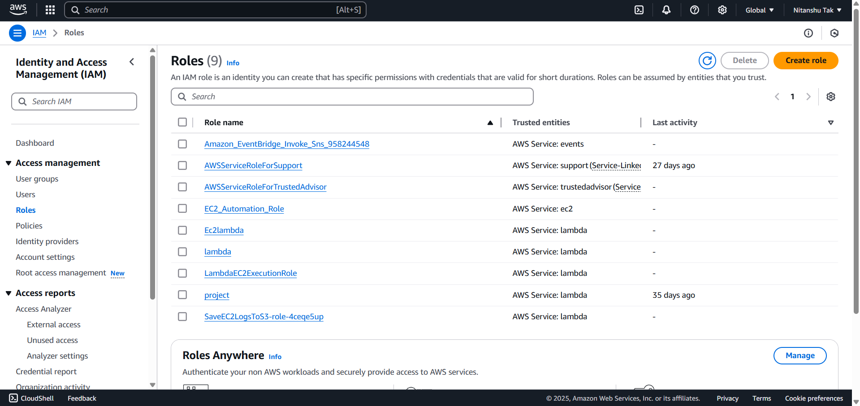

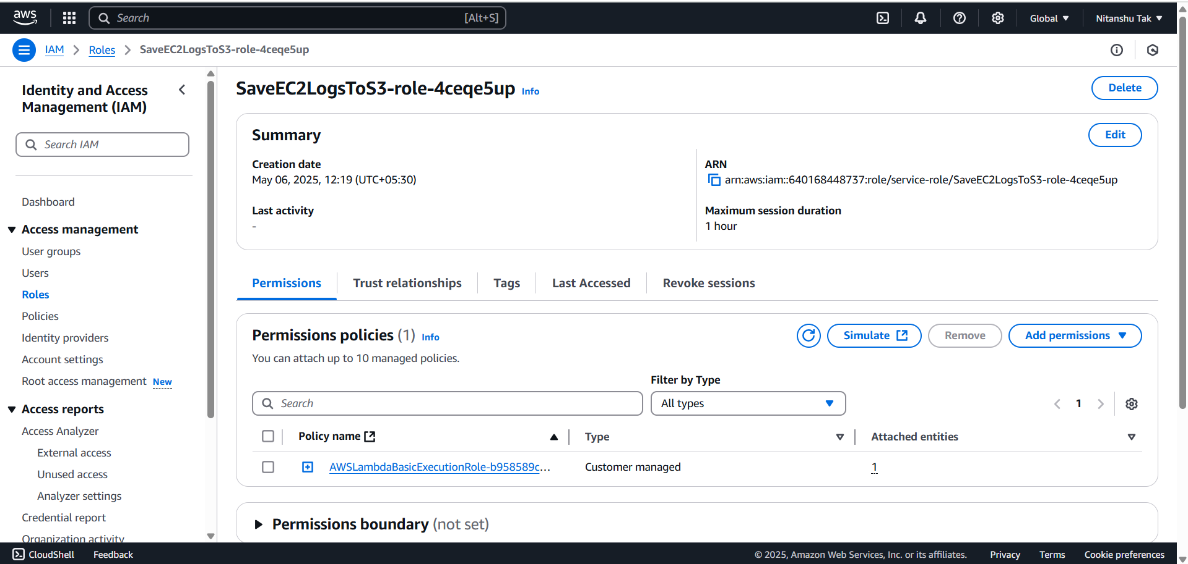

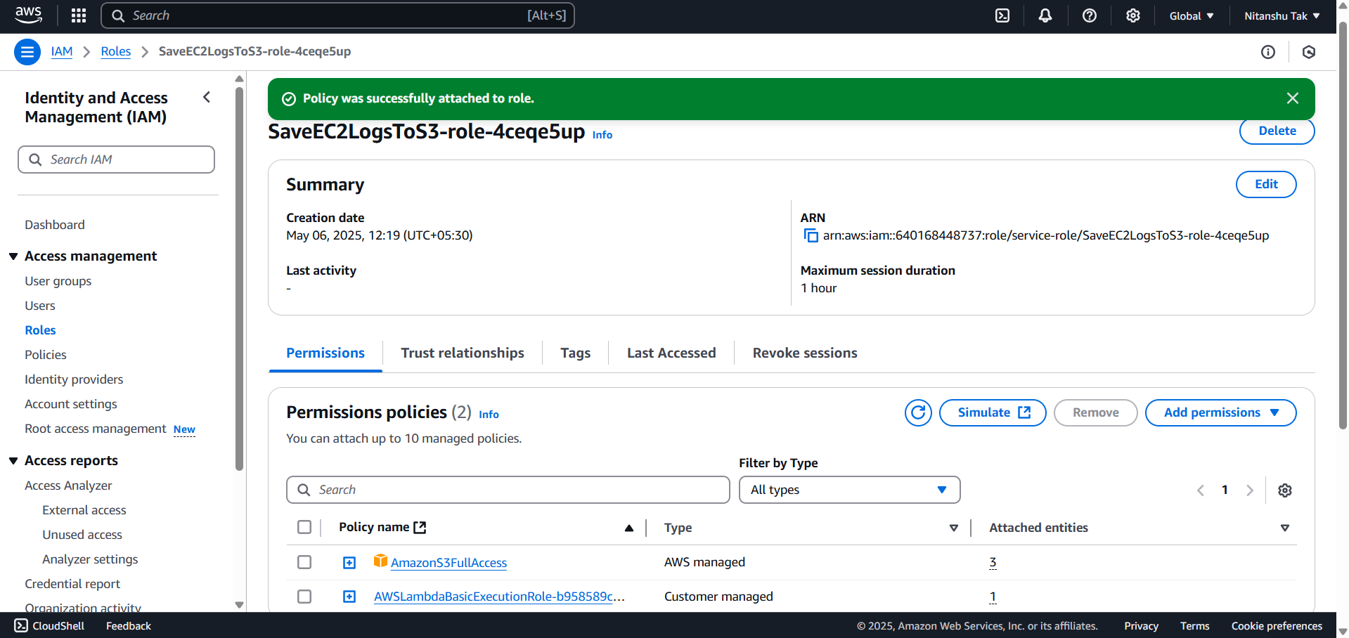

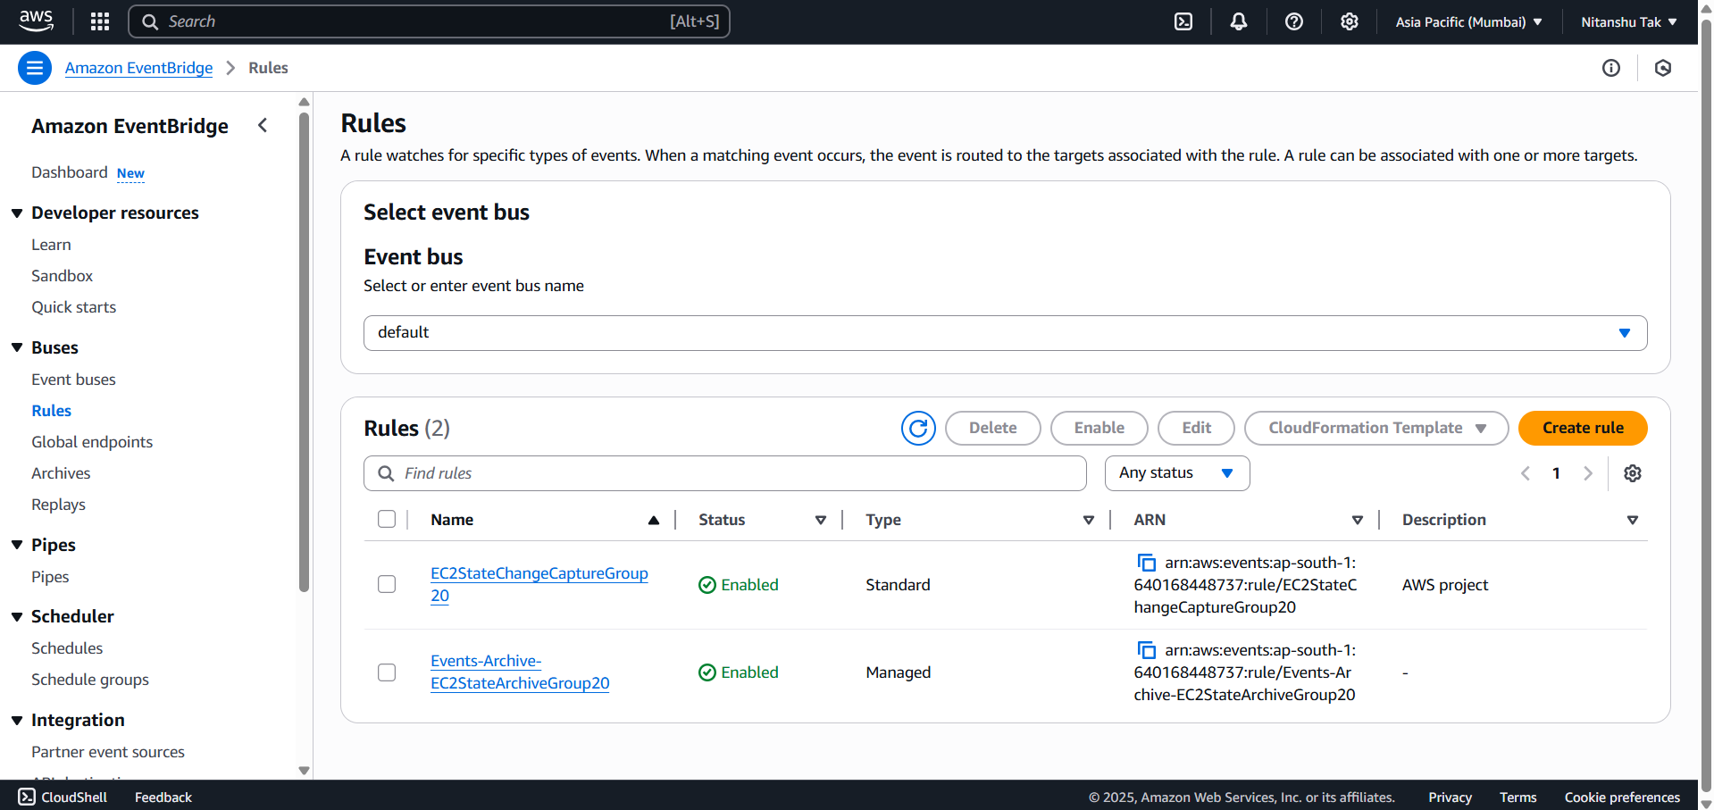

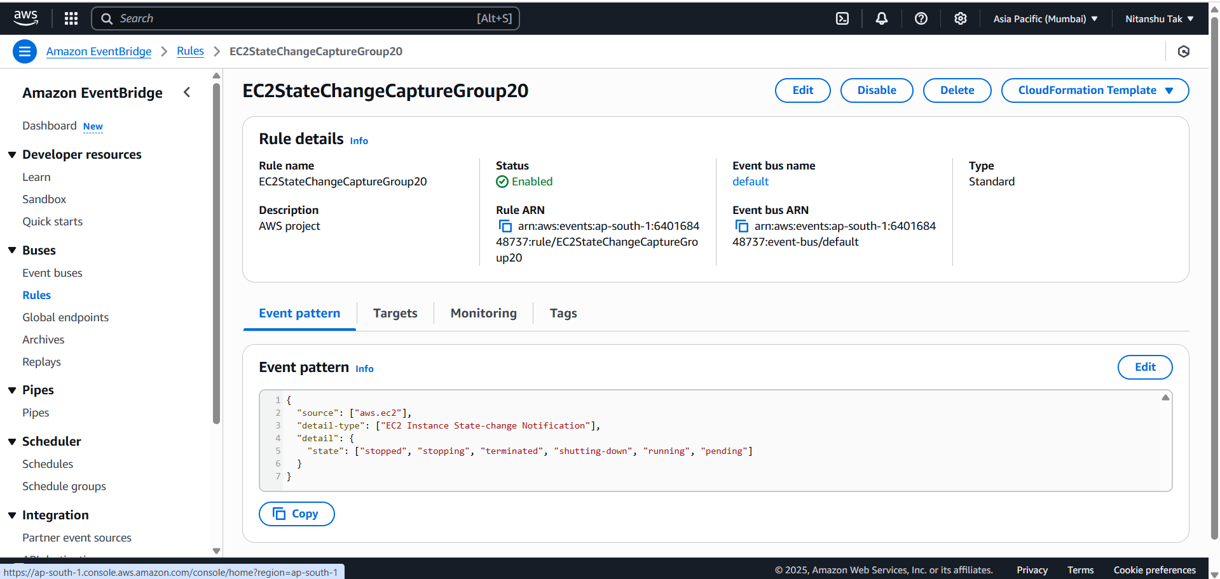

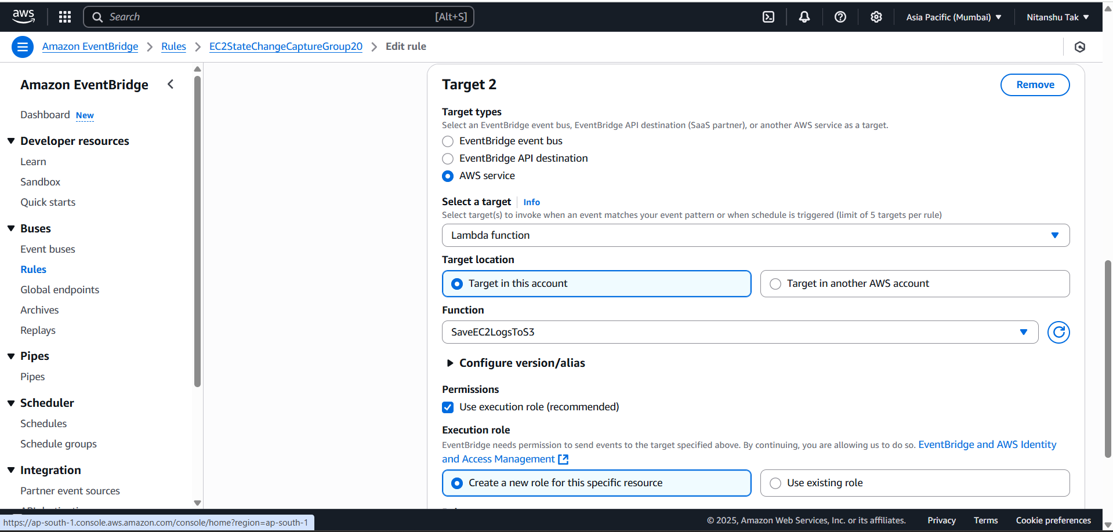

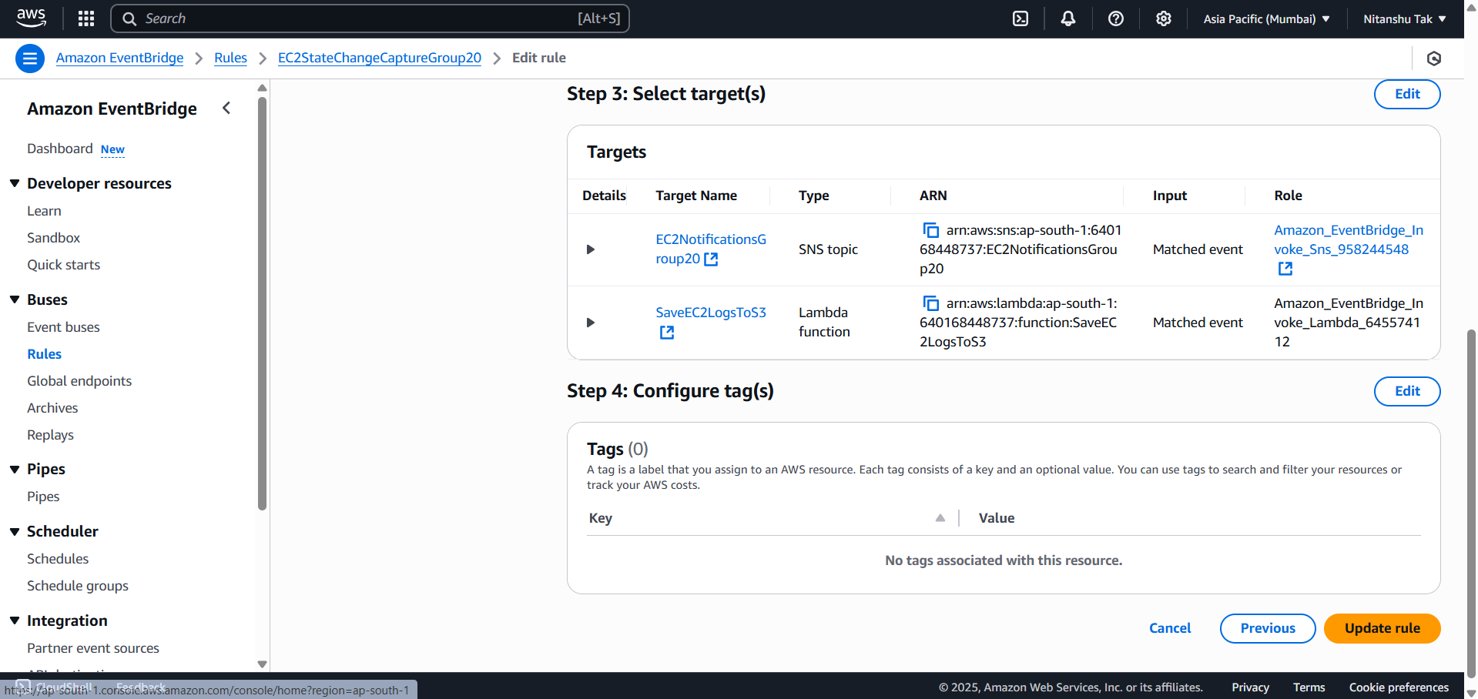

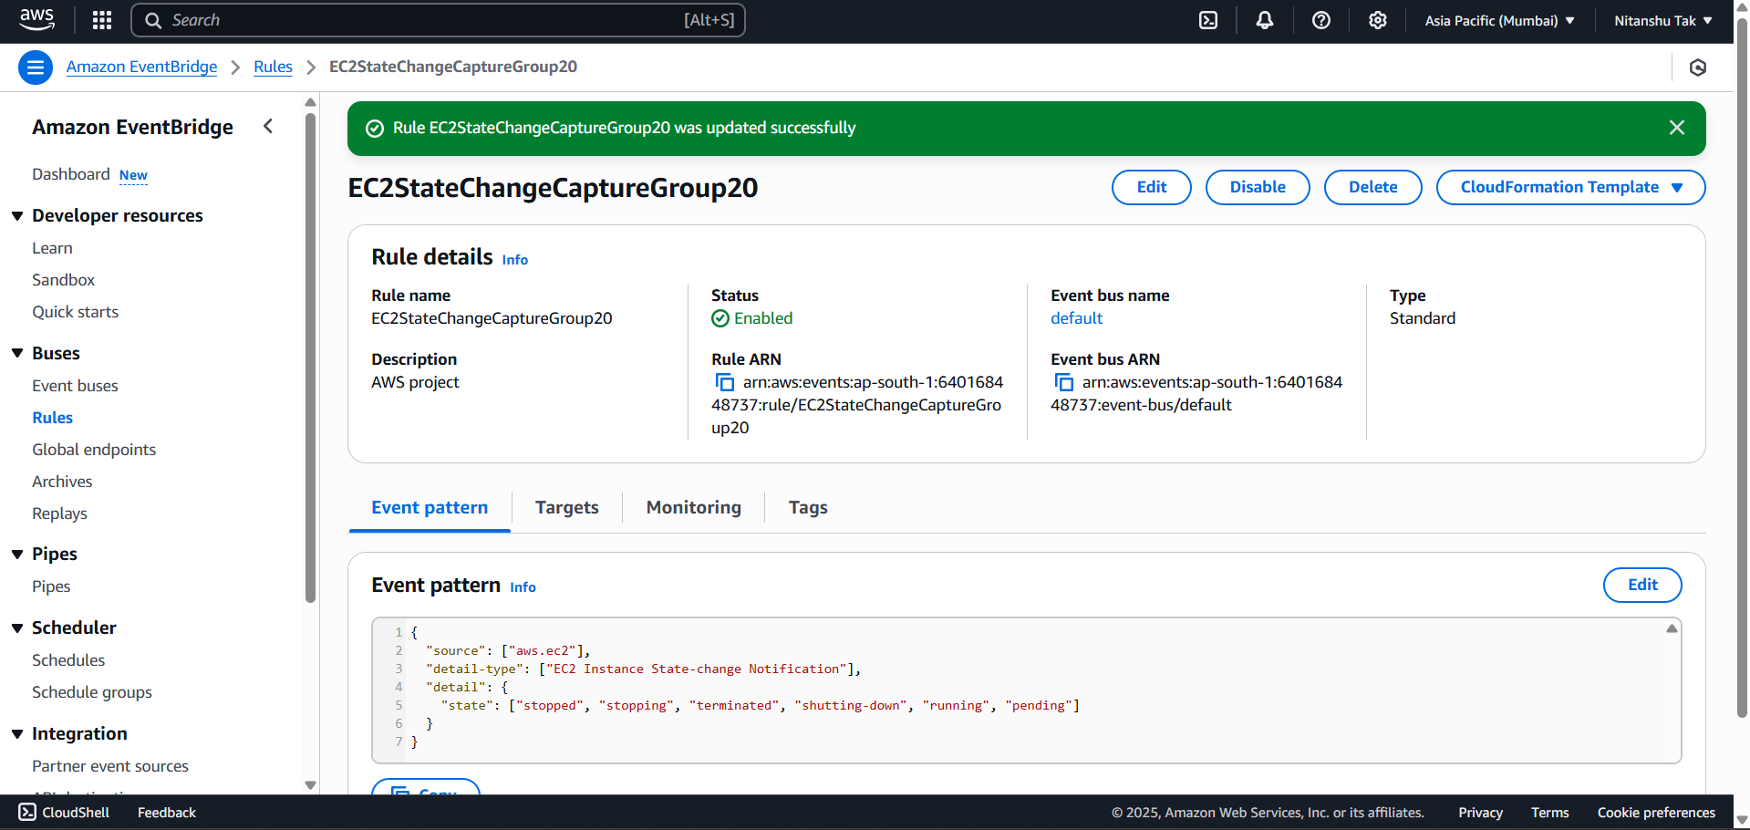

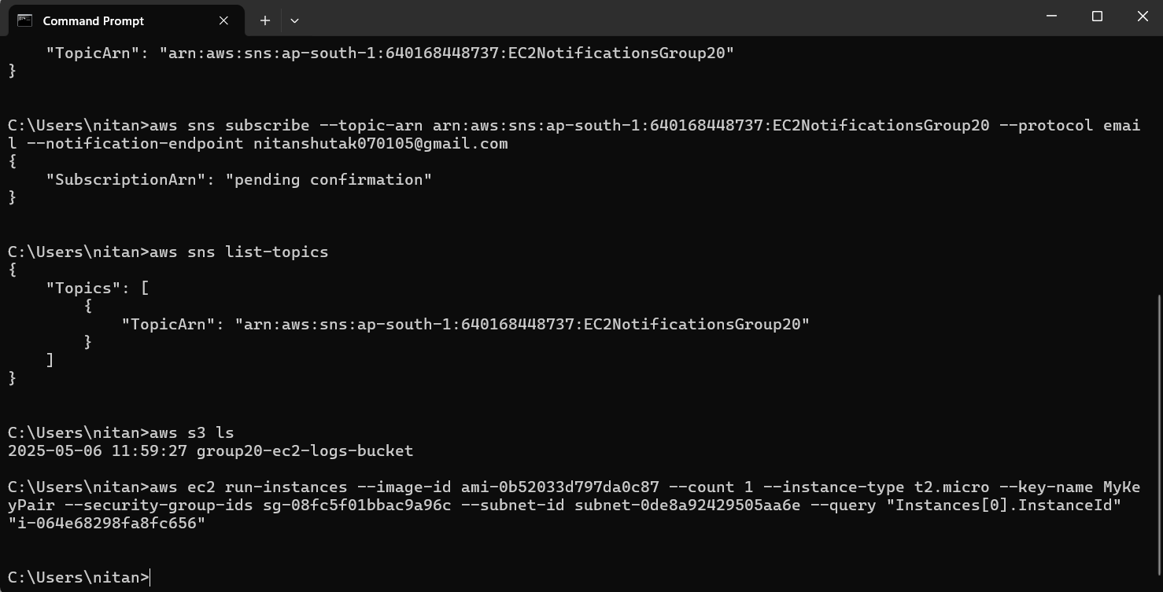

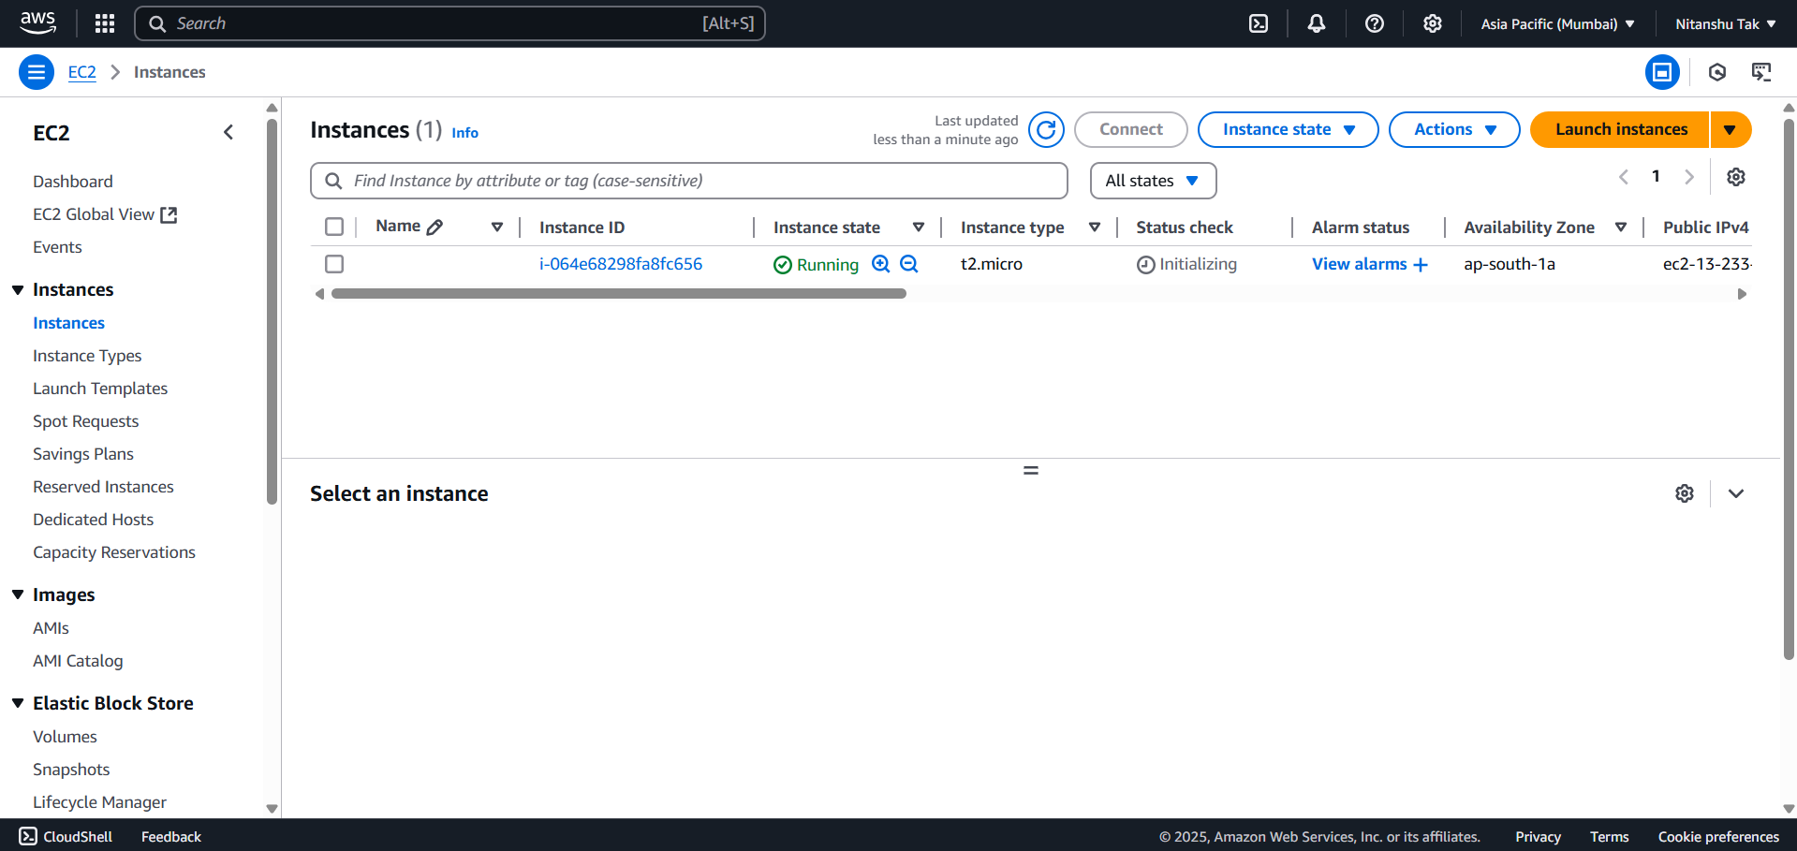

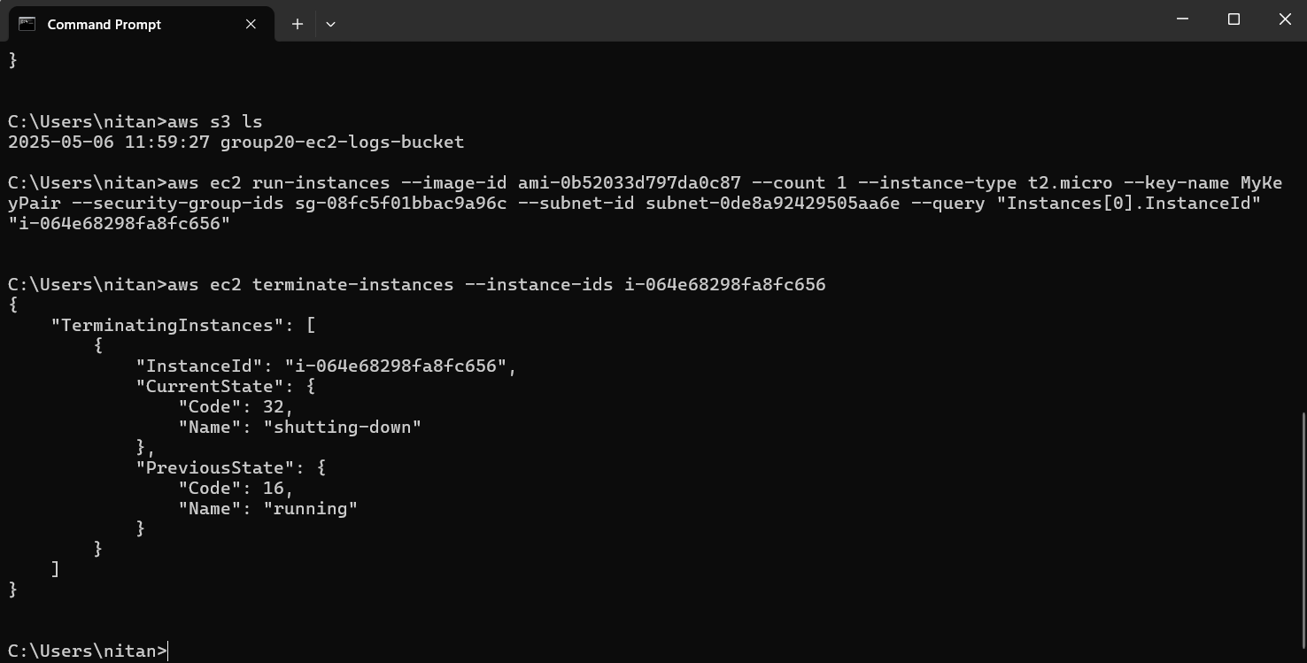

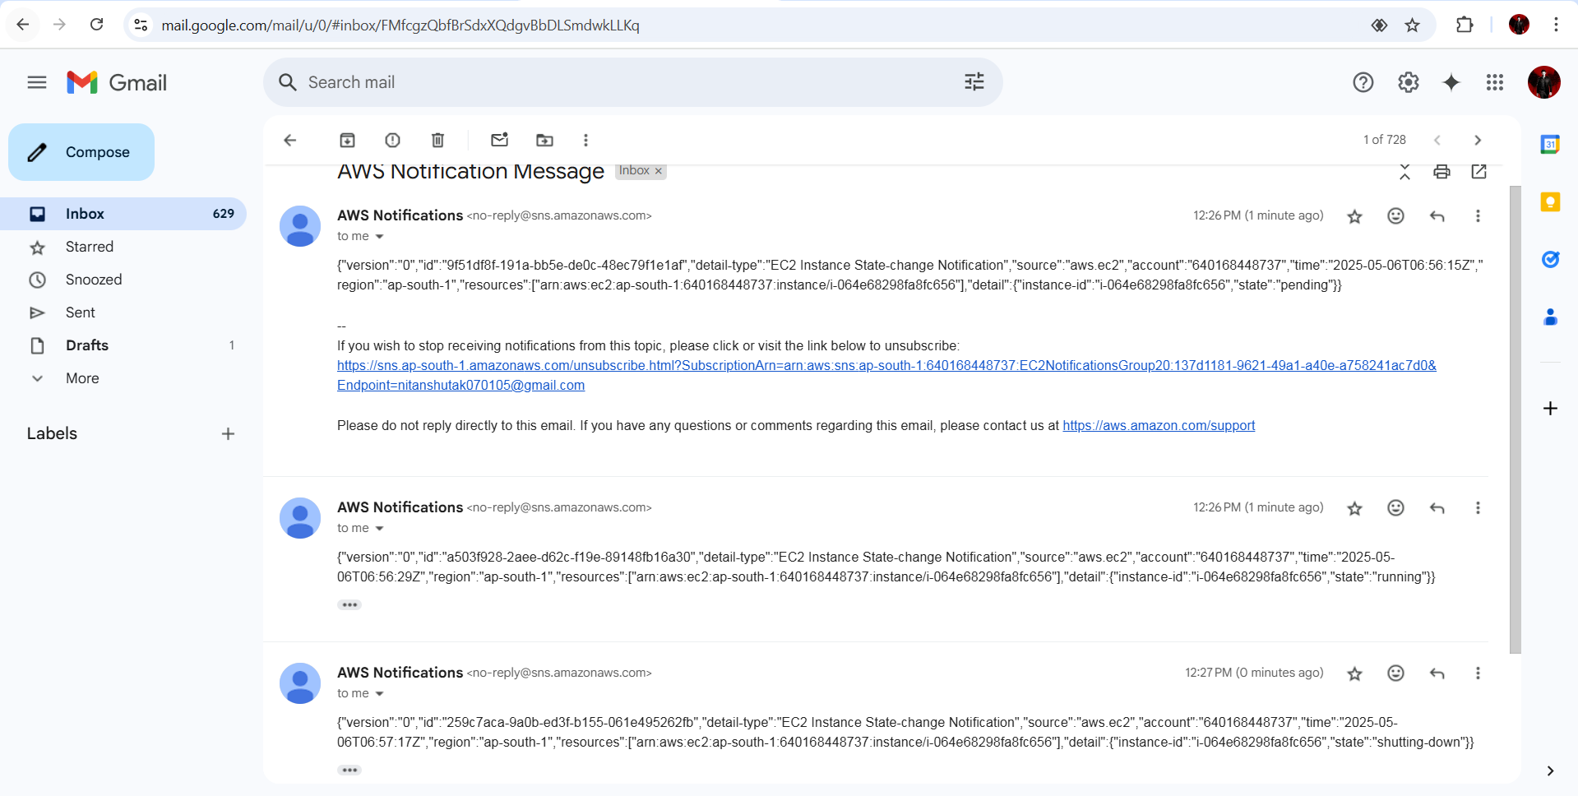

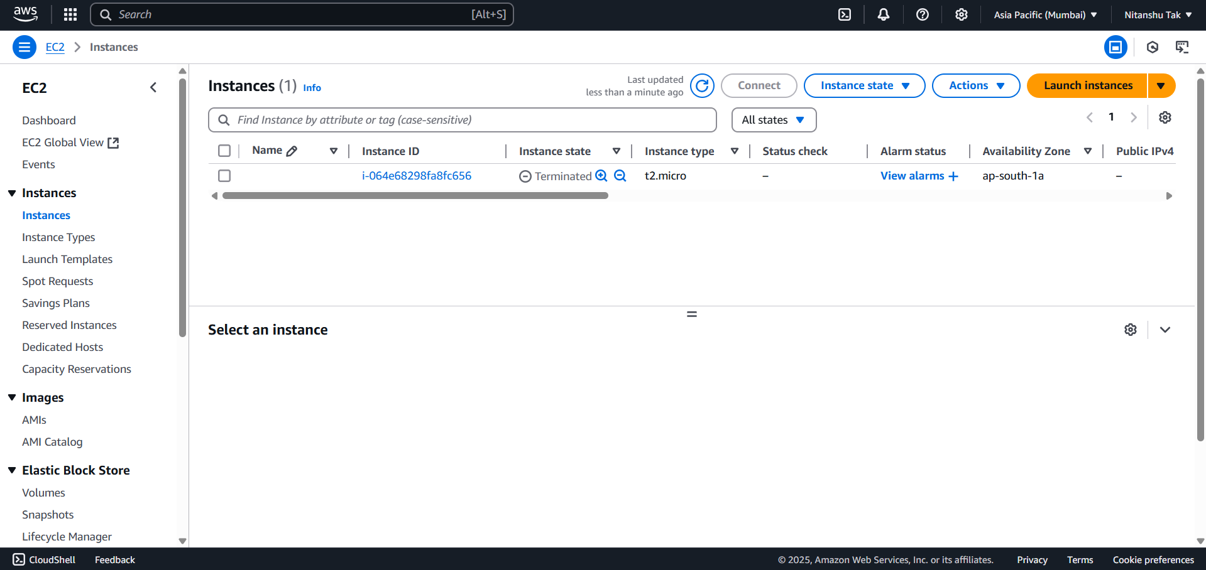

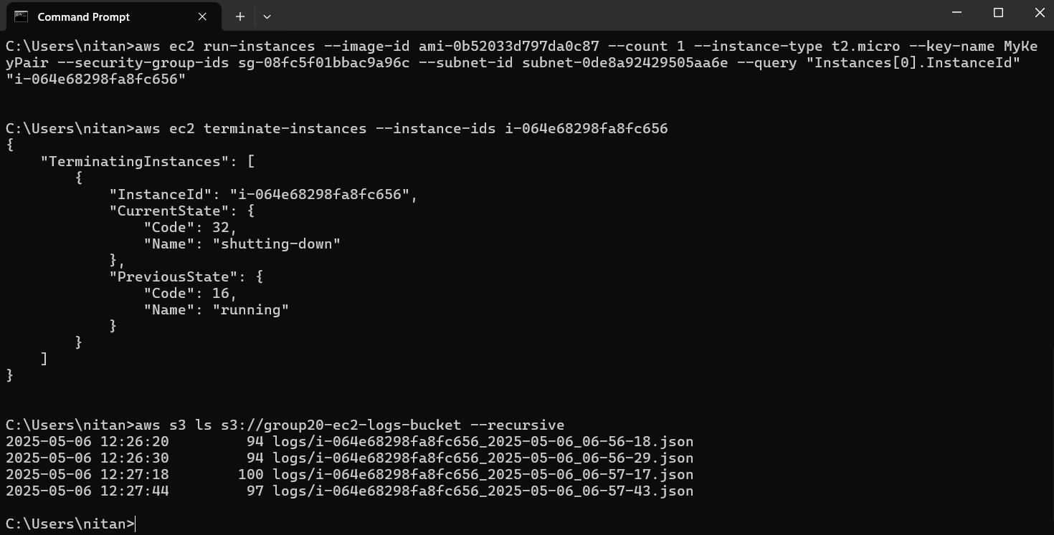

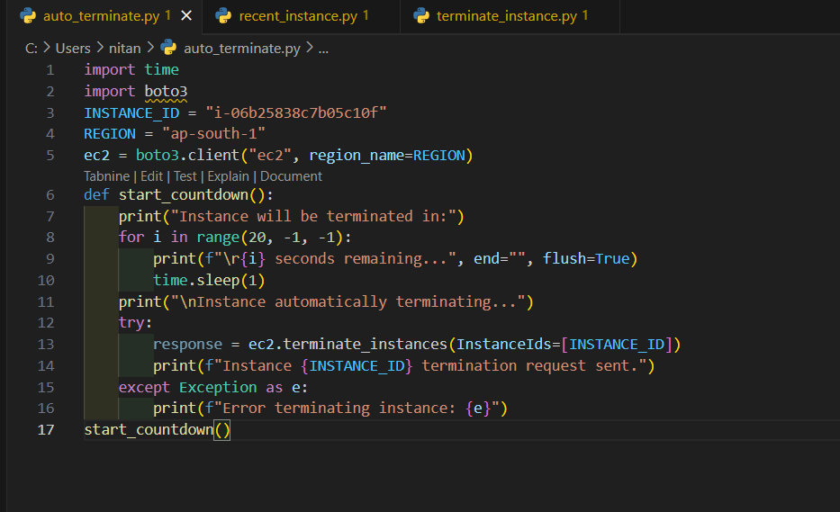

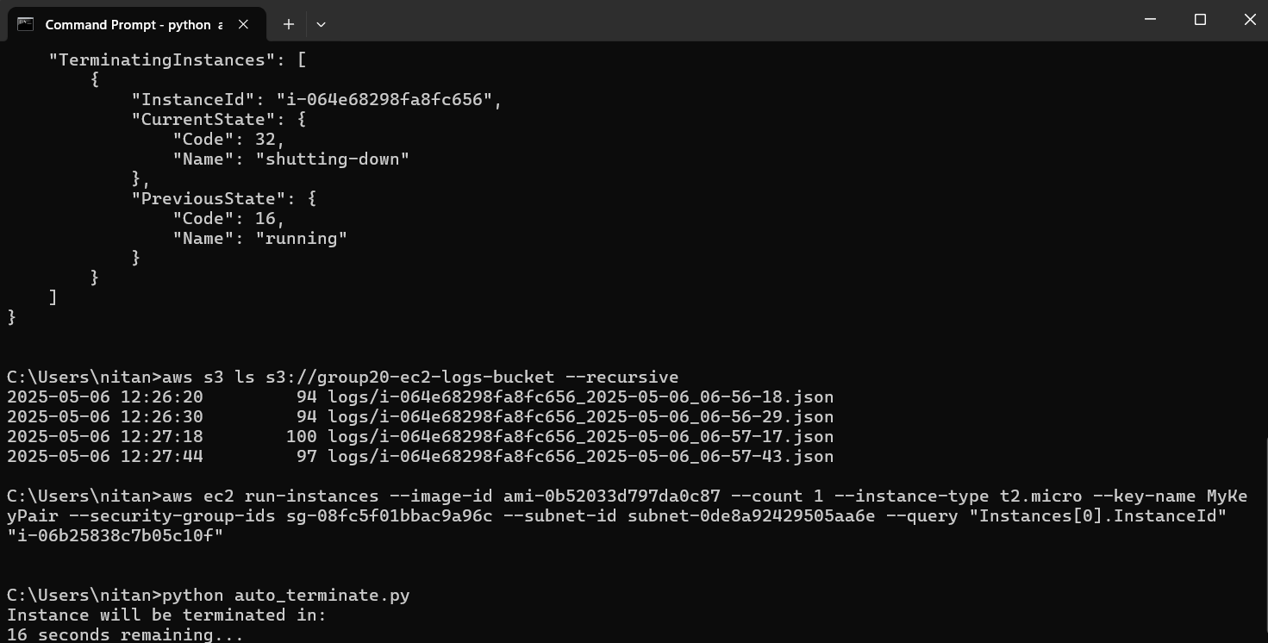

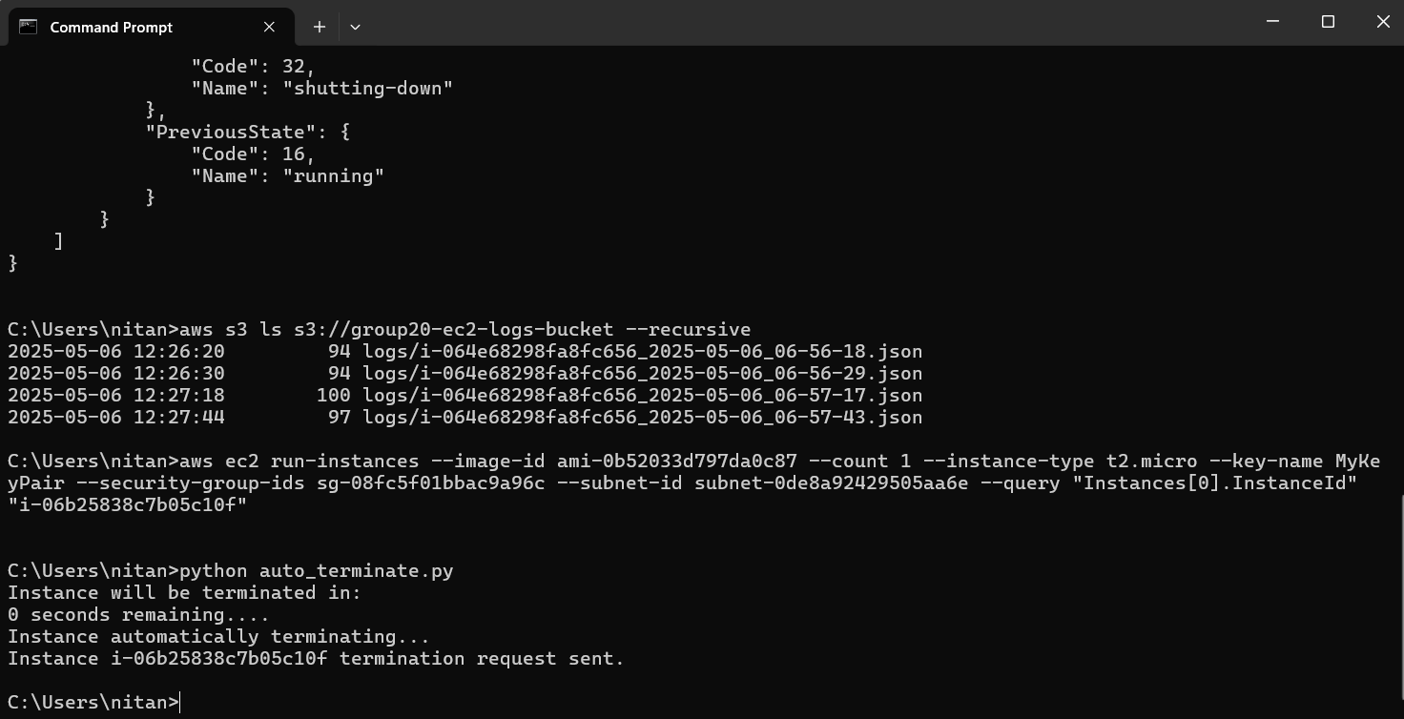

import time

import boto3

INSTANCE_ID = "i-06b25838c7b05c10f"

REGION = "ap-south-1"

ec2 = boto3.client("ec2", region_name=REGION)

def start_countdown():

    print("Instance will be terminated in:")

    for i in range(20, -1, -1):

        print(f"\r{i} seconds remaining...", end="", flush=True)

        time.sleep(1)

    print("\nInstance automatically terminating...")

    try:

        response = ec2.terminate_instances(InstanceIds=[INSTANCE_ID])

        print(f"Instance {INSTANCE_ID} termination request sent.")

    except Exception as e:

        print(f"Error terminating instance: {e}")

start_countdown()

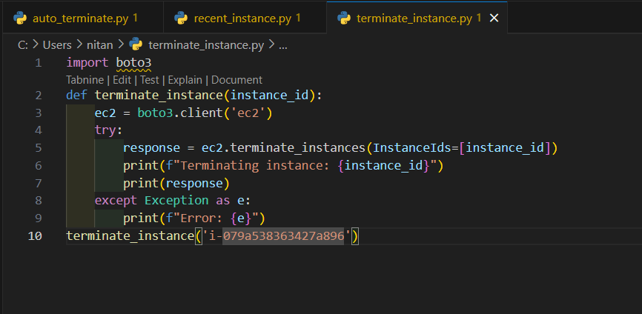

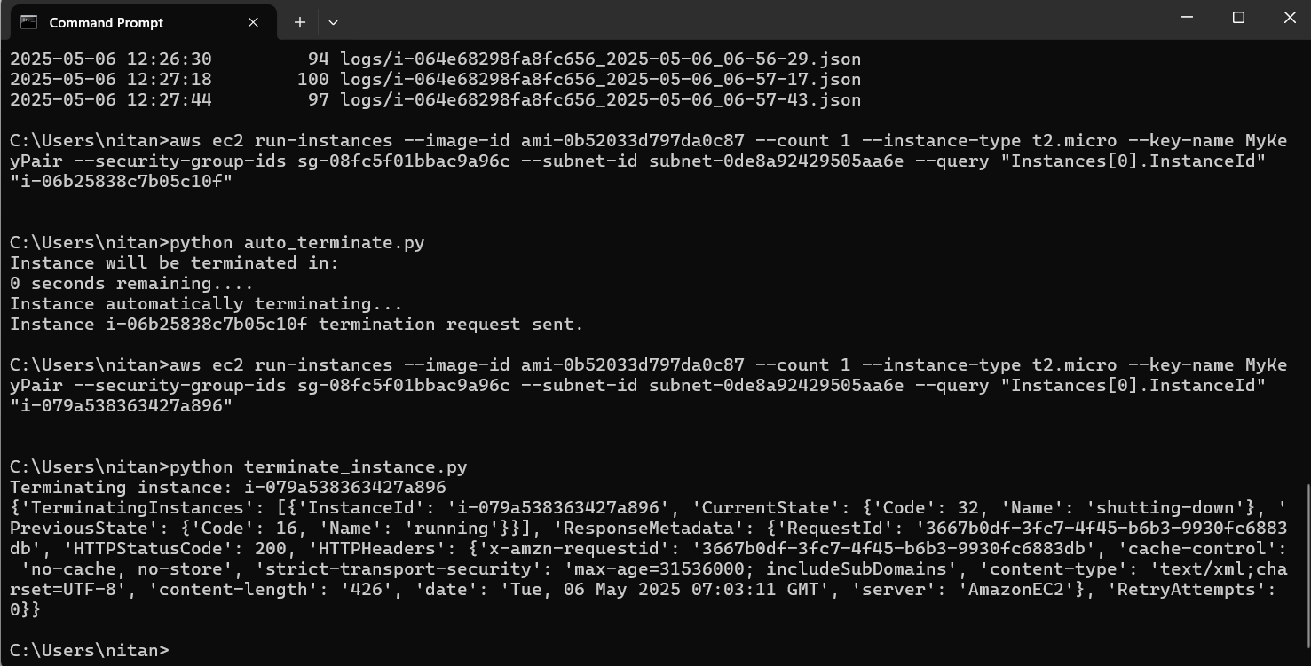

import boto3

def terminate_instance(instance_id):

    ec2 = boto3.client('ec2')

    try:

        response = ec2.terminate_instances(InstanceIds=[instance_id])

        print(f"Terminating instance: {instance_id}")

        print(response)

    except Exception as e:

        print(f"Error: {e}")

terminate_instance('i-079a538363427a896')

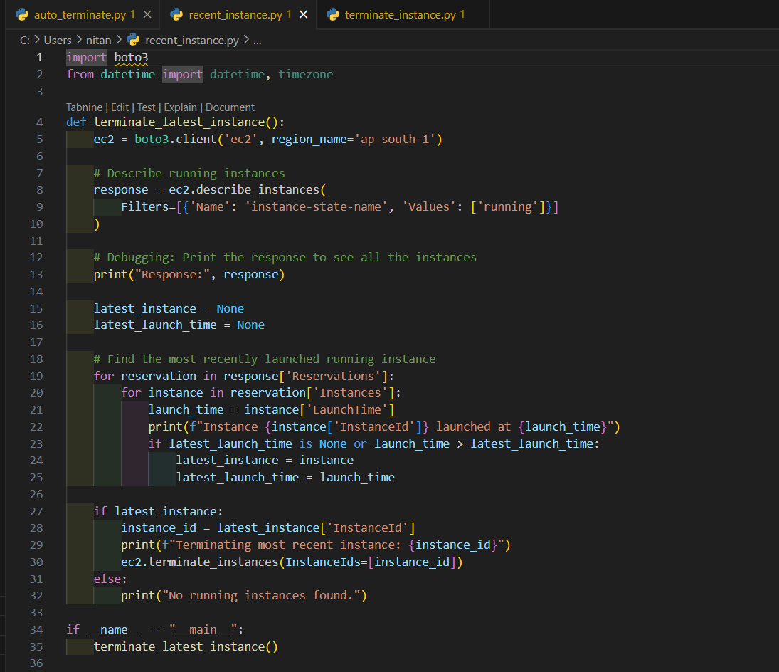



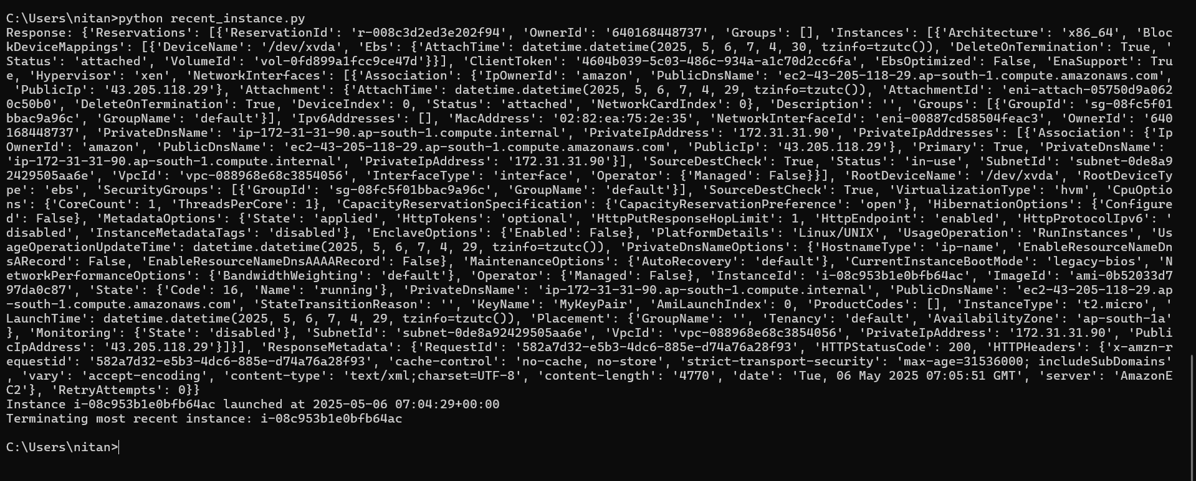

import boto3

from datetime import datetime, timezone

def terminate_latest_instance():

    ec2 = boto3.client('ec2', region_name='ap-south-1')

    # Describe running instances

    response = ec2.describe_instances(

        Filters=[{'Name': 'instance-state-name', 'Values': ['running']}]

    )

    # Debugging: Print the response to see all the instances

    print("Response:", response)

    latest_instance = None

    latest_launch_time = None

    # Find the most recently launched running instance

    for reservation in response['Reservations']:

        for instance in reservation['Instances']:

            launch_time = instance['LaunchTime']

            print(f"Instance {instance['InstanceId']} launched at {launch_time}")

            if latest_launch_time is None or launch_time > latest_launch_time:

                latest_instance = instance

                latest_launch_time = launch_time

    if latest_instance:

        instance_id = latest_instance['InstanceId']

        print(f"Terminating most recent instance: {instance_id}")

        ec2.terminate_instances(InstanceIds=[instance_id])

    else:

        print("No running instances found.")

if __name__ == "__main__":

    terminate_latest_instance()

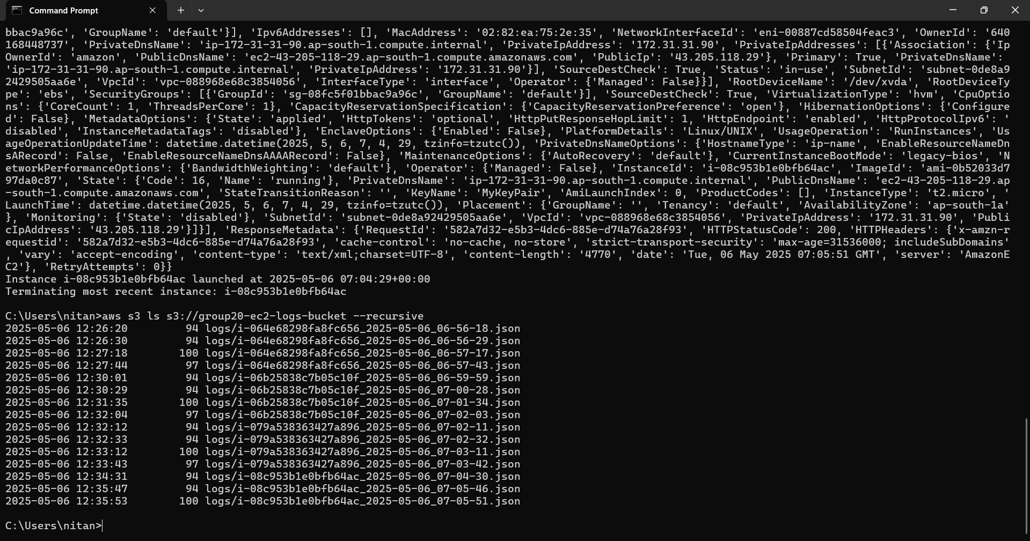

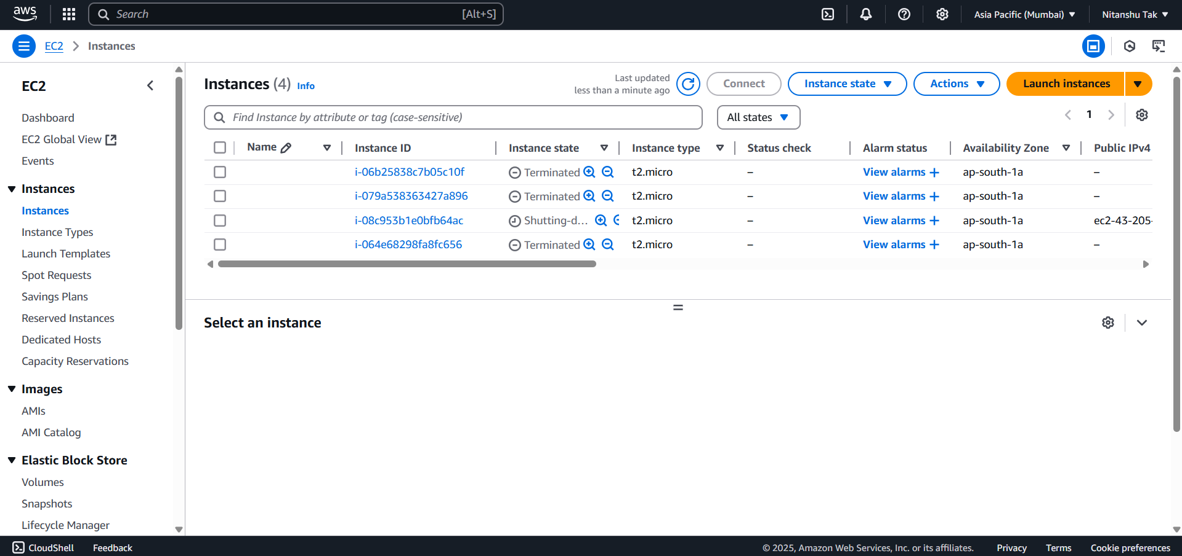



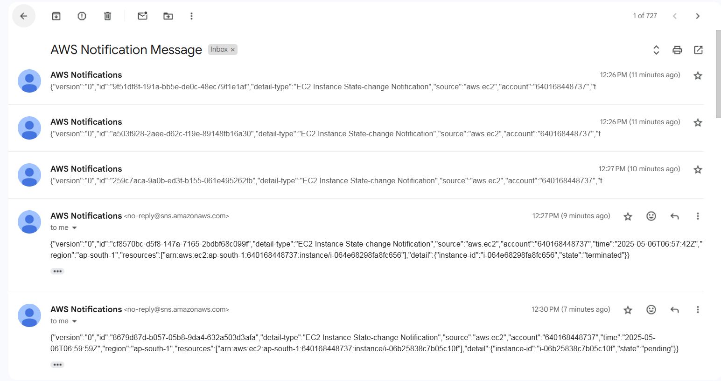

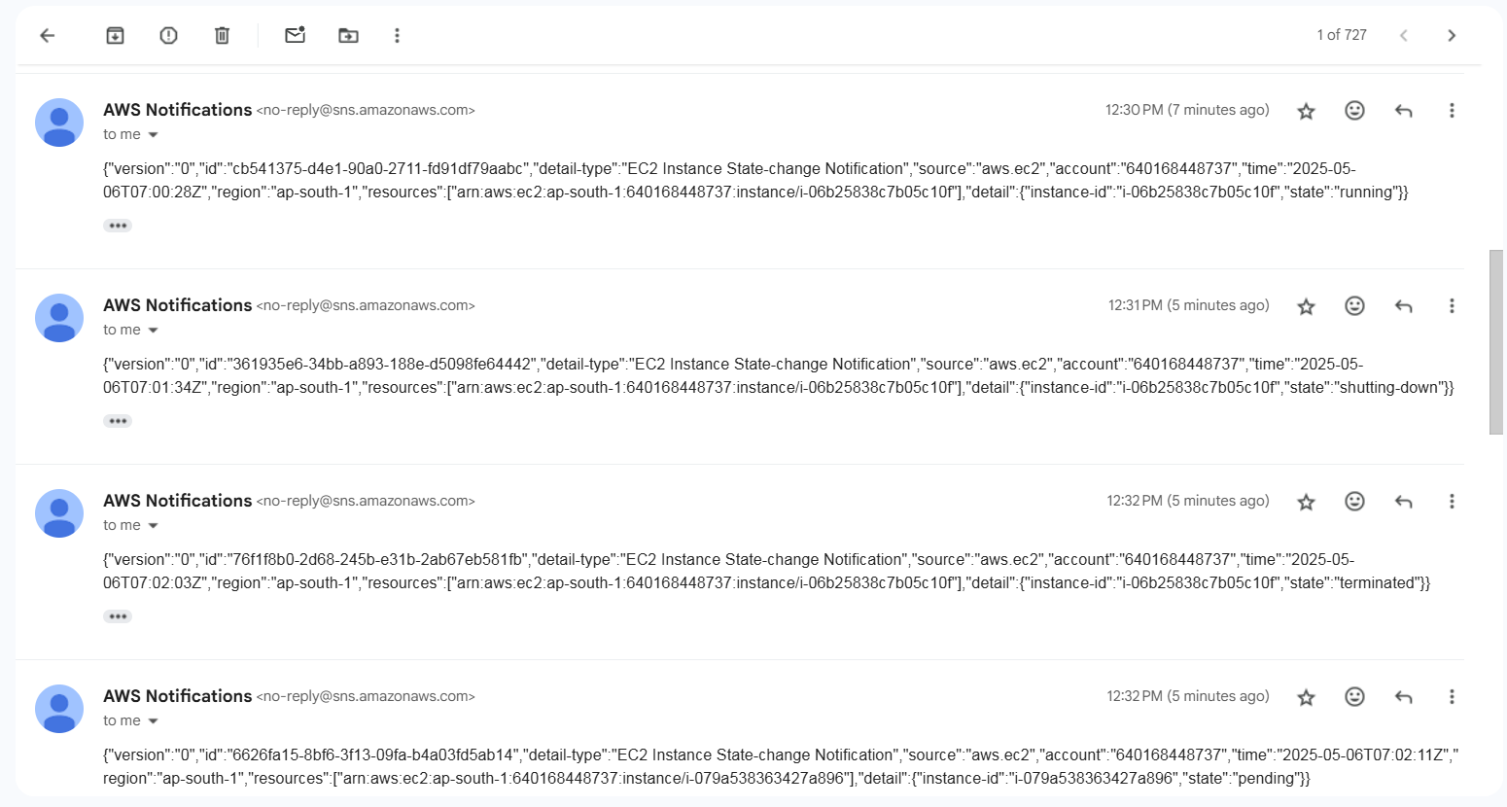

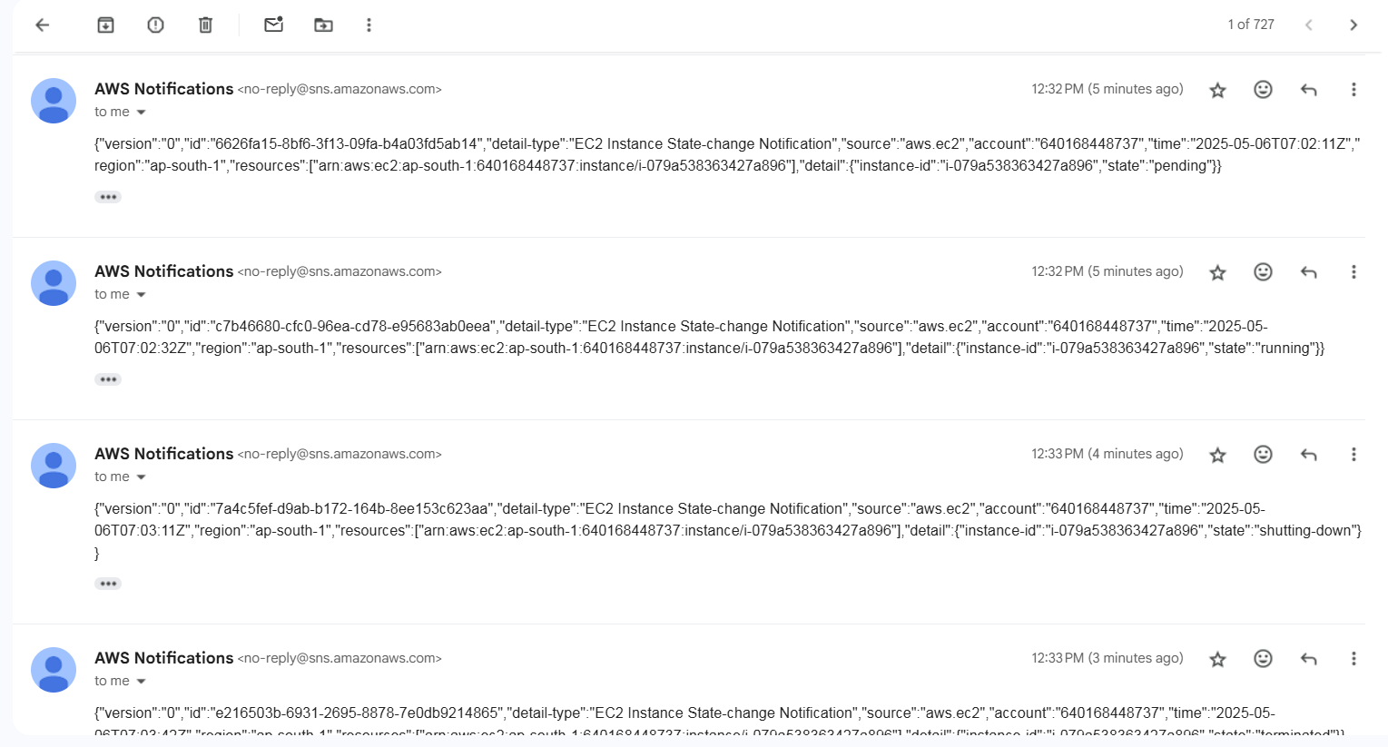

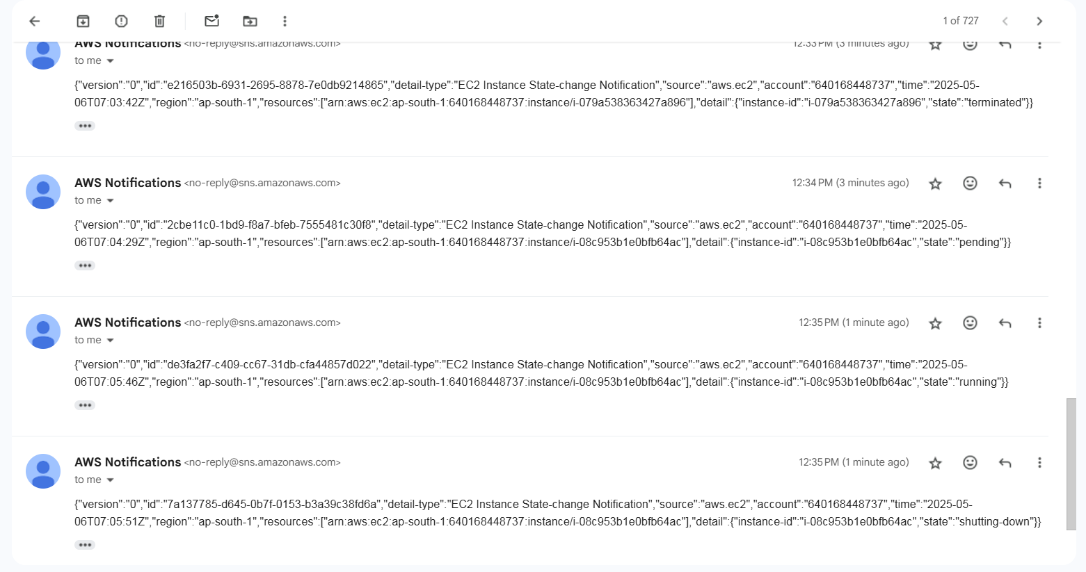

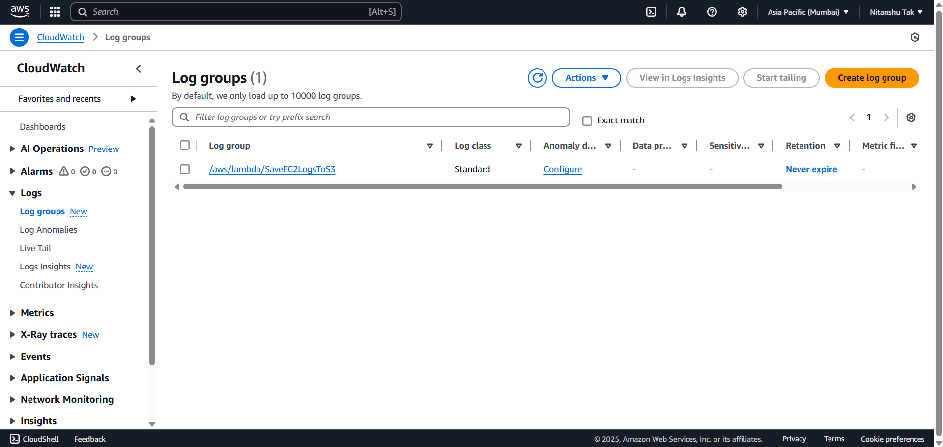

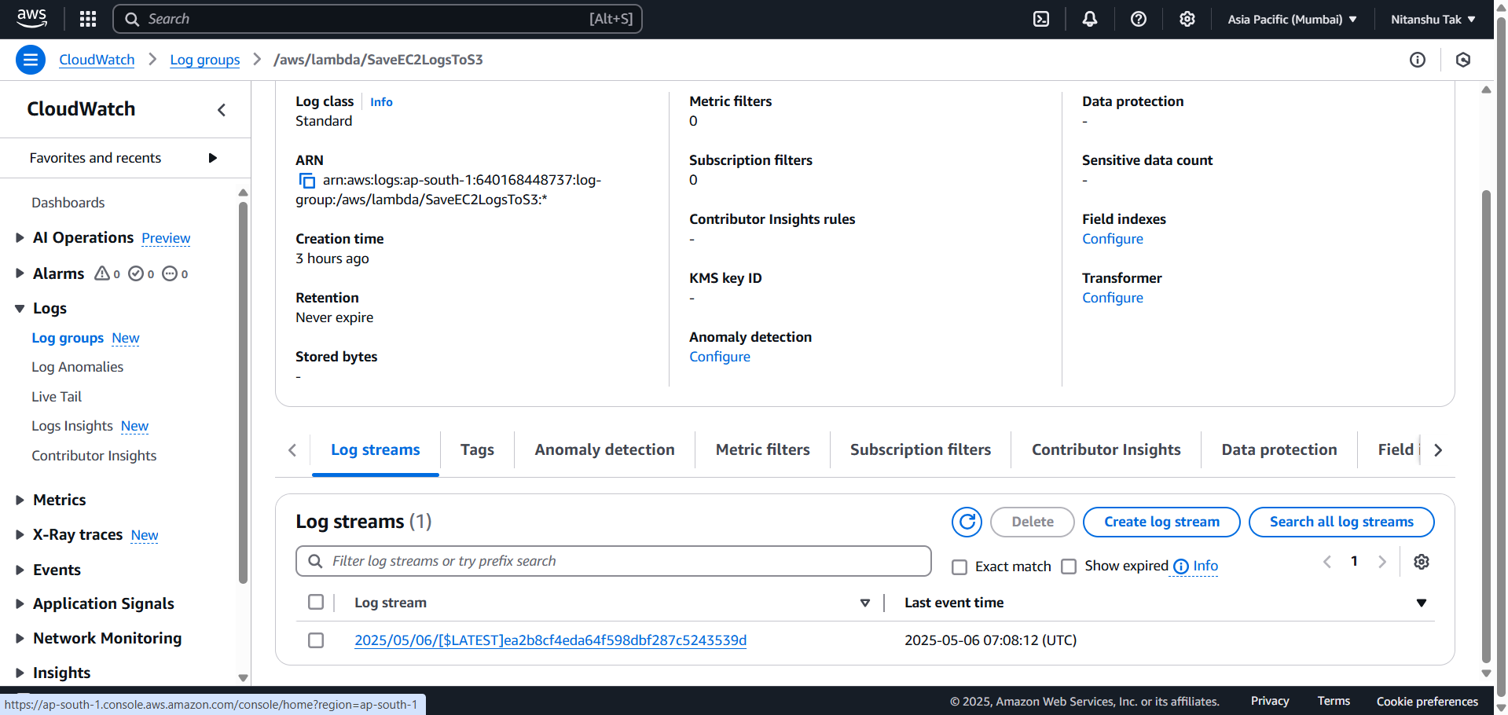

1. **At the end, delete everything to avoid billings**